

**BMSCE ACM Student Chapter**

B.M.S. College Of Engineering

Email: [acm@bmsce.ac.in](mailto:acm@bmsce.ac.in)

**&**

**RVCE ACM Student Chapter**

R.V. College Of Engineering

Email: [acm@rvce.edu.in](mailto:acm@rvce.edu.in)



**ACM India Chapter Summit 2024: Summary Report**

**Introduction**

The ACM India Chapter Summit 2024, hosted by B.M.S. College of Engineering (BMSCE) and R.V. College of Engineering (RVCE) on December 20th and 21st, explored the theme "Sustainable Computing".

The event united ACM Chapters all over India, fostering a sense of community, inspiring societal contributions, and building lasting connections among ACM Student Chapters, Professional Chapters, Special Interest Group Chapters (SIGs), and ACM-W Chapters.

This commitment to sustainability was reflected in all aspects of the event, from eco-friendly materials like jute bags, ID cards, plant pots and steel bottles to plastic-free banners and serving plates.

**Summary of the Programme:**

**DAY 0 - 19th December 2024**

The day started with participants check-ins, where attendees arrived. This allowed participants to get familiar with the venue and the agenda for the summit.

* 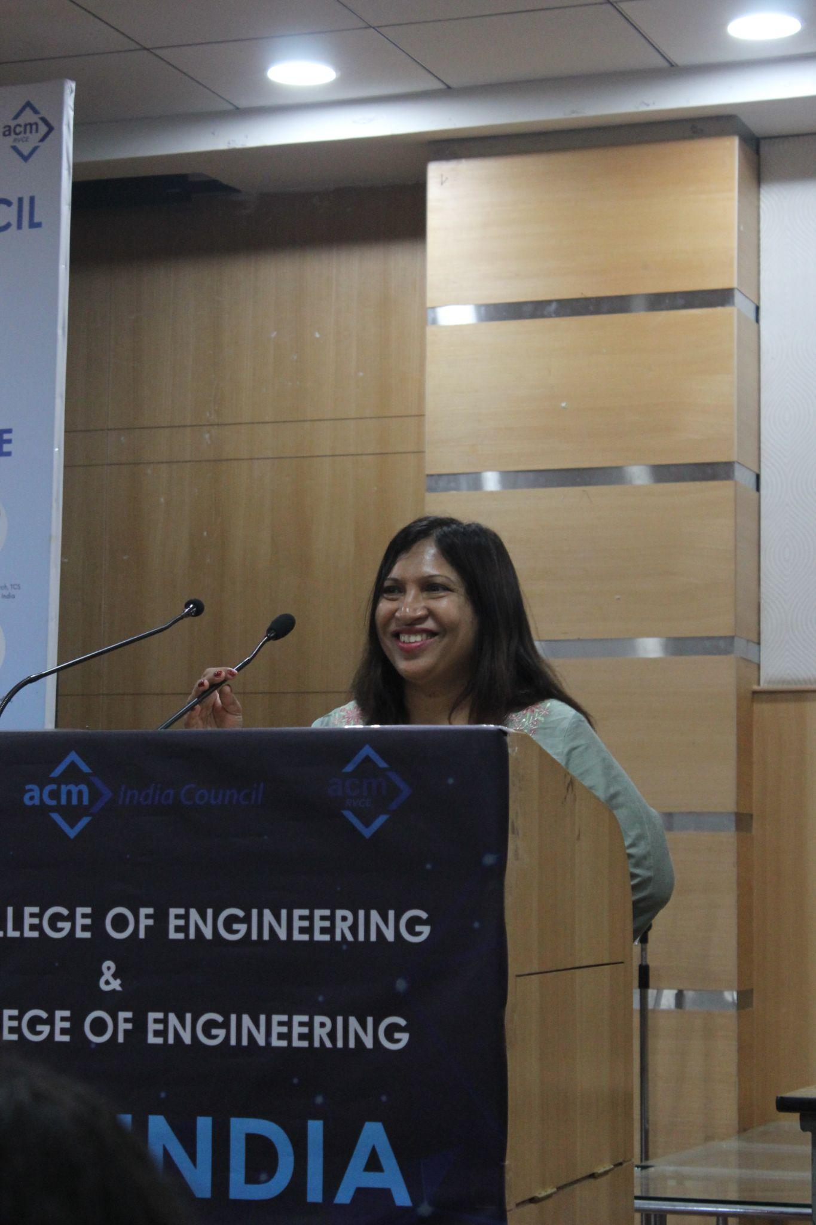**Session 1: Addressing by ACM India Council Member**

Following the check-ins, the crowd was warmly addressed by **Ms. Maria Dsouza Choudhary**, Principal Engineer at Oracle India and an ACM India Council Member. In her address, she shared valuable insights into the **ACM Ambassador Program**, highlighting its objectives and significance in fostering leadership, collaboration, and a vibrant ACM community.

To better understand the participants and their respective ACM chapters, details about nearby ACM and non-ACM chapters, past activities over the last two years, plans for the next 2-3 months, and proposed initiatives for the coming year were collected through a Google Form. The form also gathered information on the frequency of chapter meets, collaborations with other chapters, social media presence, usage of ACM India ESP, and feedback on the ACM India Chapter Portal.

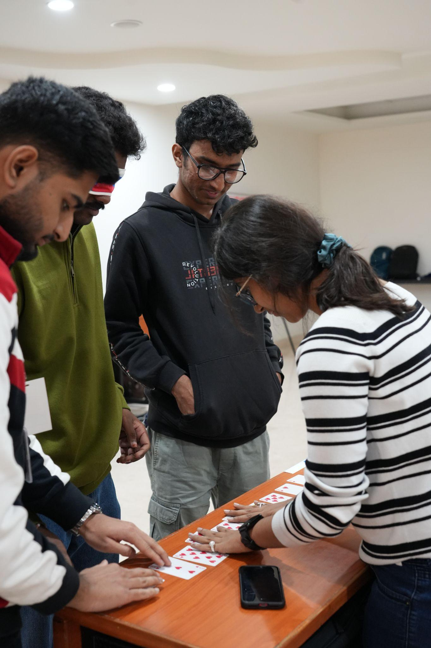

* **Session 2: Duos Dash**

Later, attendees participated in a lively networking activity titled **"Duos Dash".** This session paired individuals randomly, encouraging them to step out of their comfort zones and engage in quick discussions or fun challenges with their partners. It was an enjoyable way to break the ice, build new connections, and bring in a spirit of enthusiasm among the diverse group of attendees.

The day concluded with a delightful **welcome dinner**, where participants relaxed and bonded over delicious food in an informal setting. It was a perfect opportunity for attendees to reflect on the day's events, share their experiences, and build anticipation for the exciting sessions planned for the following days.

**DAY 1 - 20th December 2024**

### **8:00 AM to 9:00 AM – Breakfast & Registration**

The day began with a hearty breakfast, during which participants registered for the summit. It was an opportunity for attendees to mingle with peers, connect with event organizers, and familiarize themselves with the day's schedule. Registration included the distribution of ID badges and summit kits, ensuring everyone was ready for the sessions ahead.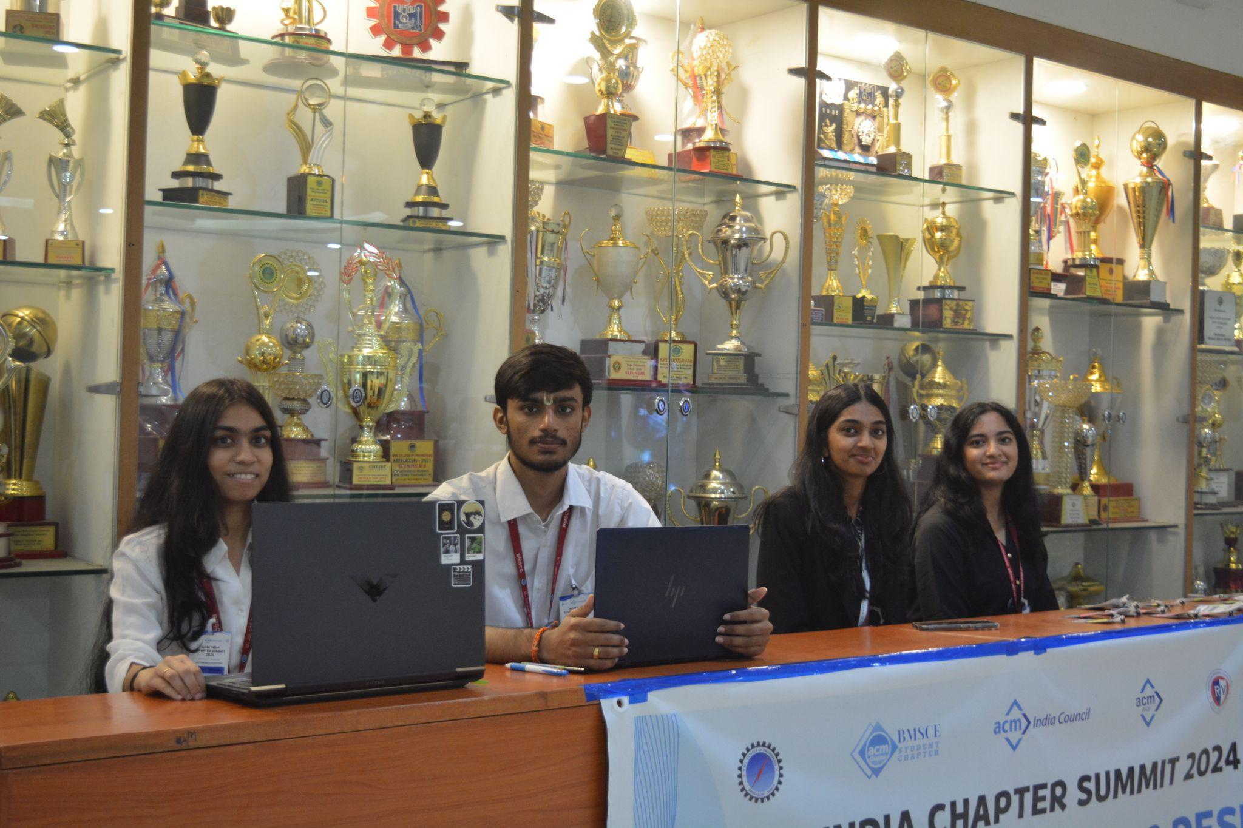

* **9:00 AM to 9:10 AM – Welcome by BMSCE Students & Paramvah**

The Eastern Dance Team of BMSCE, Paramvah, performed a vibrant and energetic welcome dance that celebrated India’s rich cultural heritage. This captivating performance set the stage for the day, leaving the audience in awe and setting an enthusiastic tone for the sessions to follow.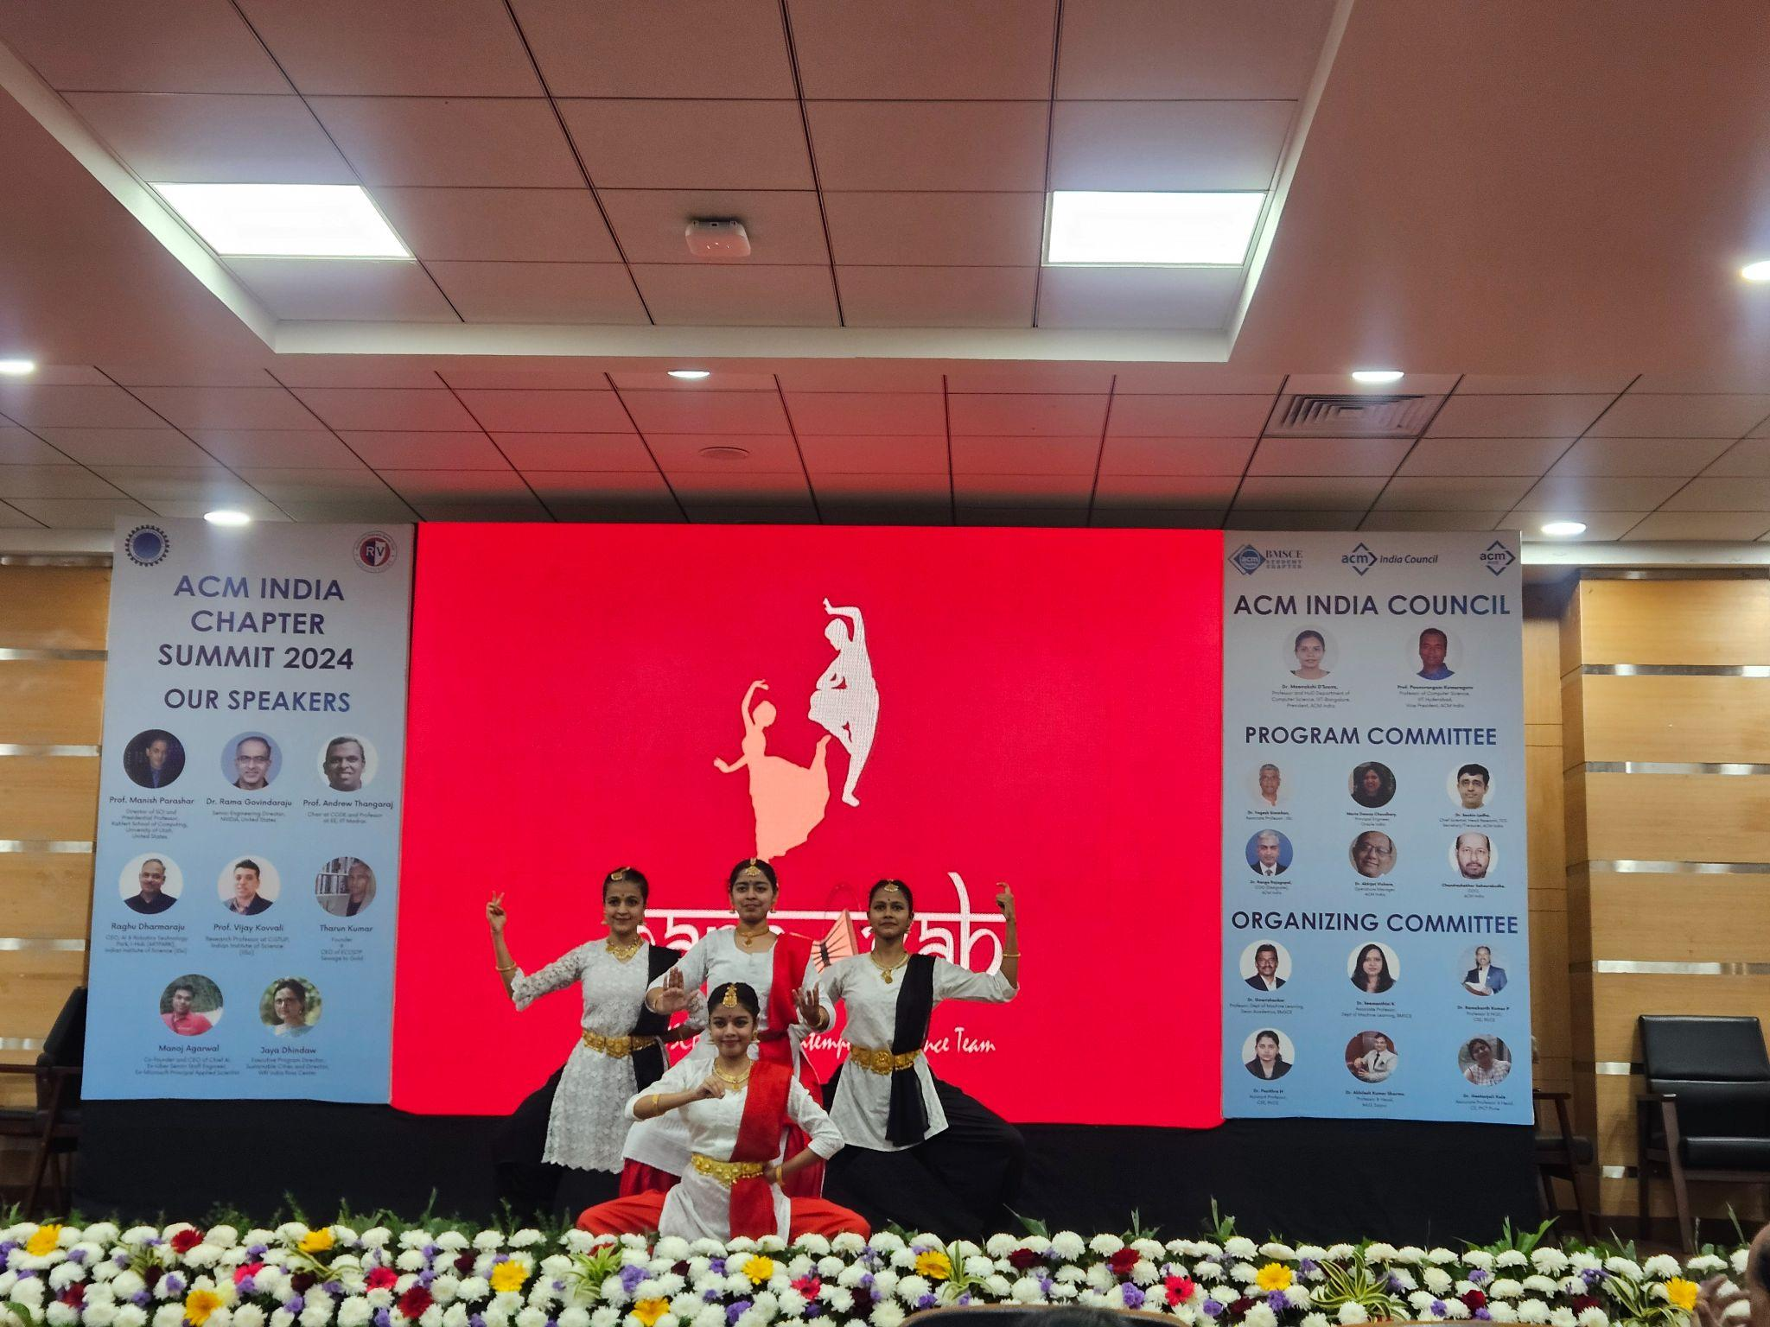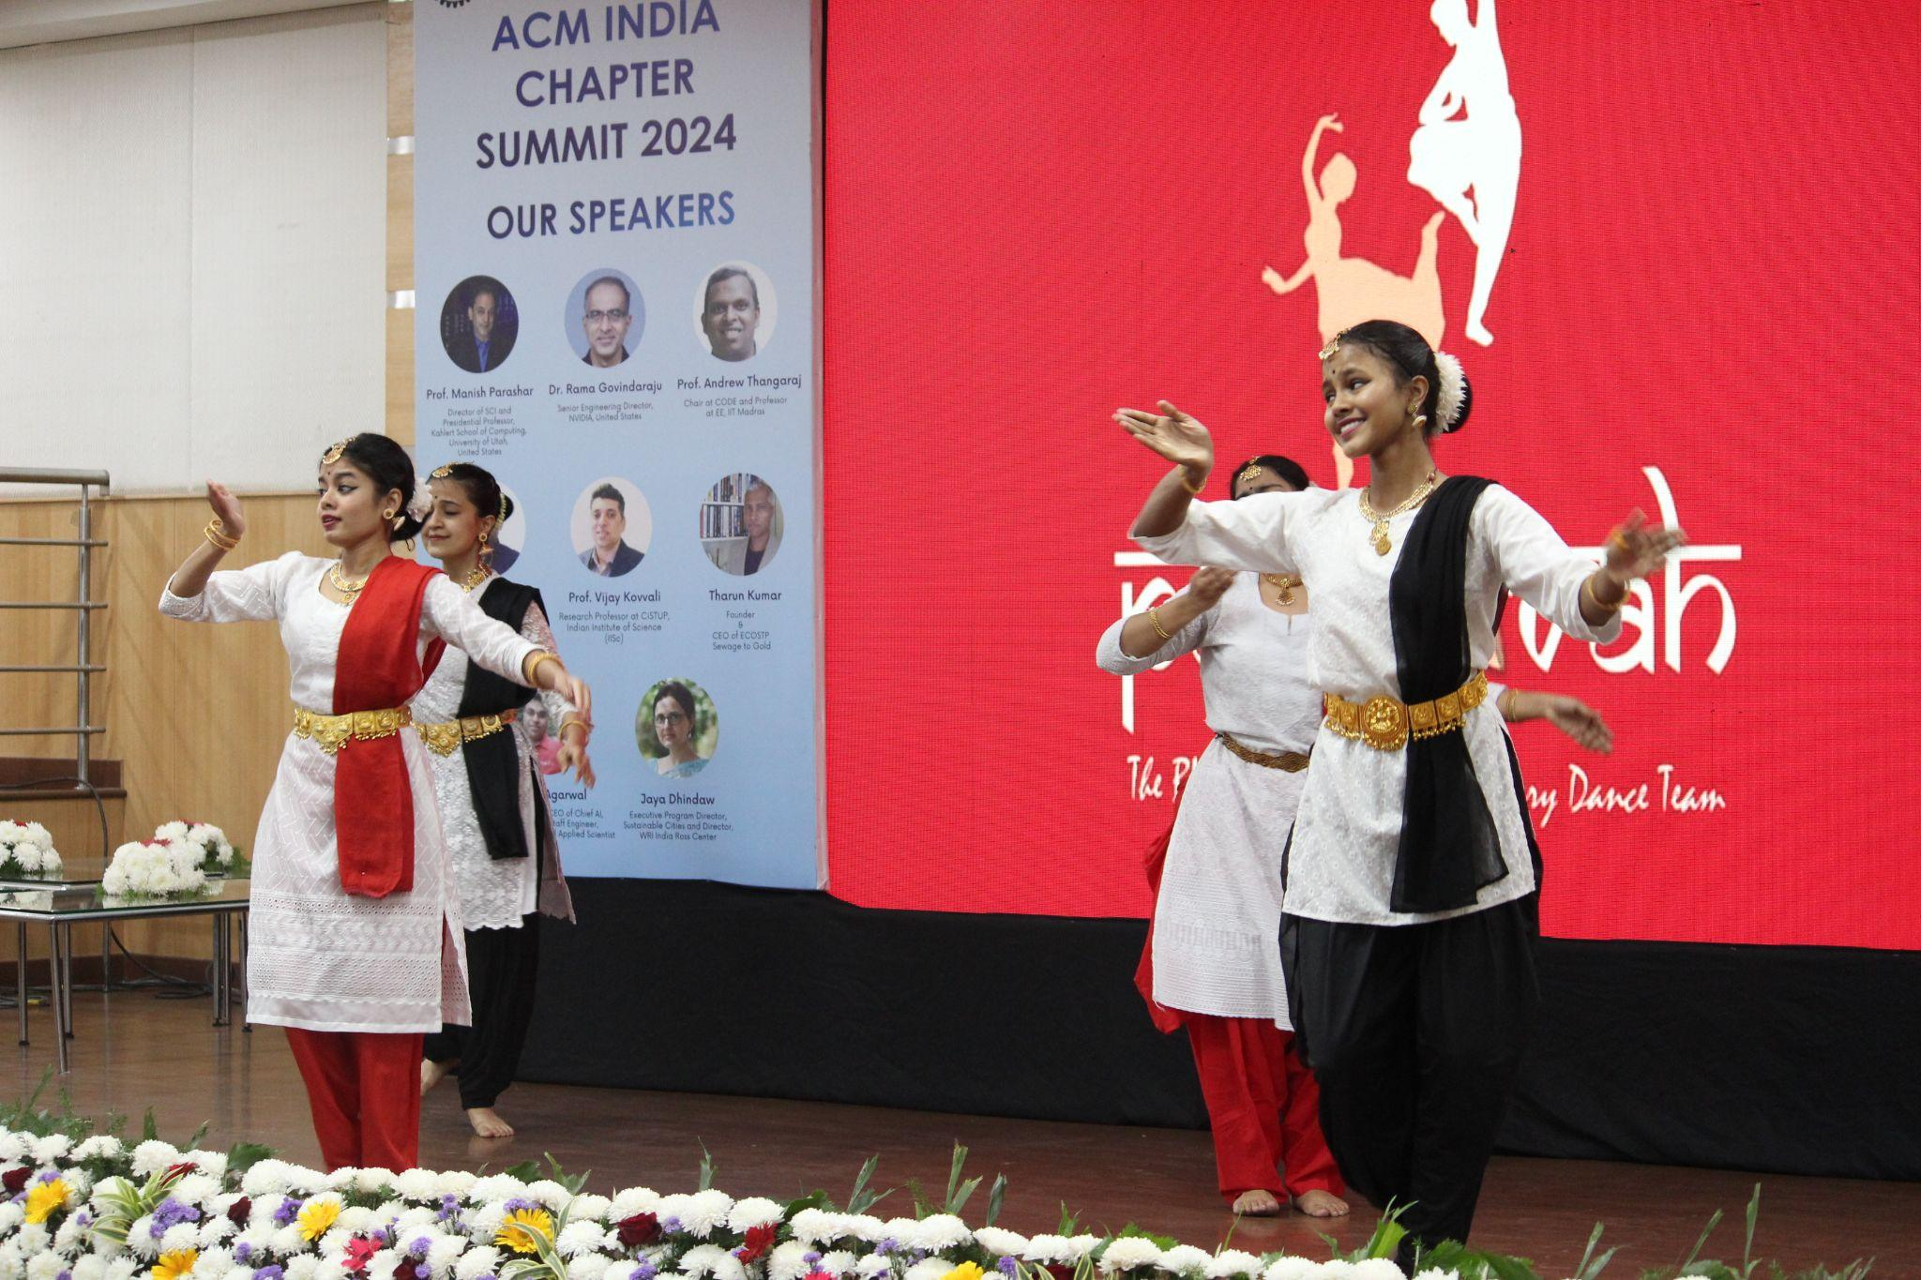

* **9:10 AM to 9:15 AM – Welcome Note from ACM India**

The event’s formal proceedings began with a welcome note by **Dr. Yogesh Simmhan**, Associate Professor at IISc, and **Ms. Maria Dsouza Choudhary**, Principal Engineer at Oracle India. They highlighted the significance of the ACM India Chapter Summit, its role in uniting the computing community, and its focus on the theme of sustainable computing.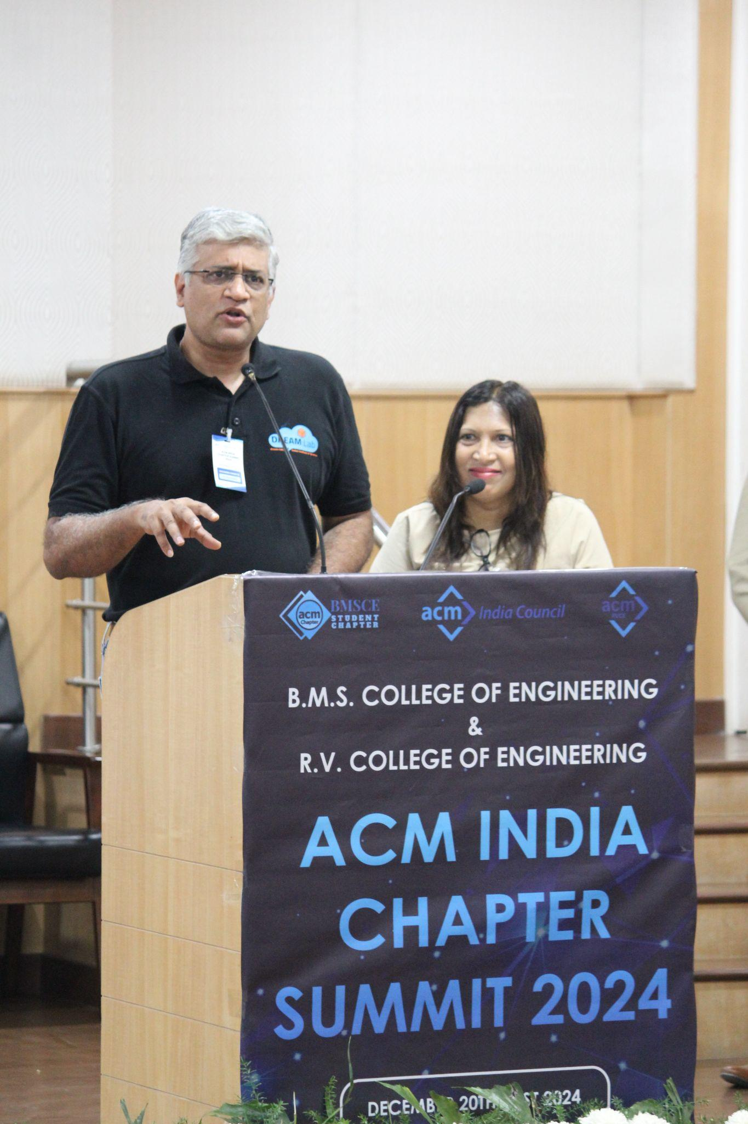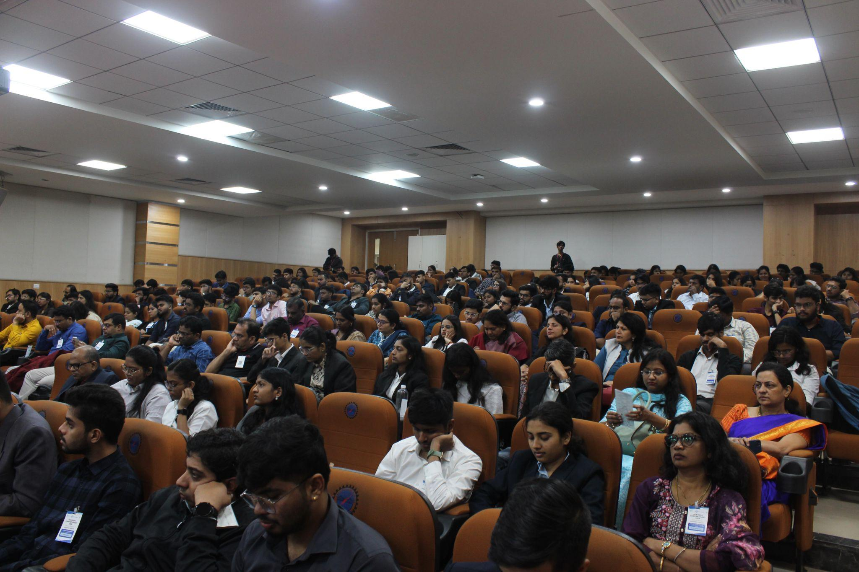

* **9:15 AM to 9:30 AM – Talk by Meenakshi D’Souza, President, ACM India**

**Dr. Meenakshi D’Souza**, President of ACM India, delivered an inspiring talk outlining ACM India’s vision and mission. She emphasized the organization’s dedication to advancing computing as a science and profession, promoting innovation, and empowering the next generation of computing professionals.

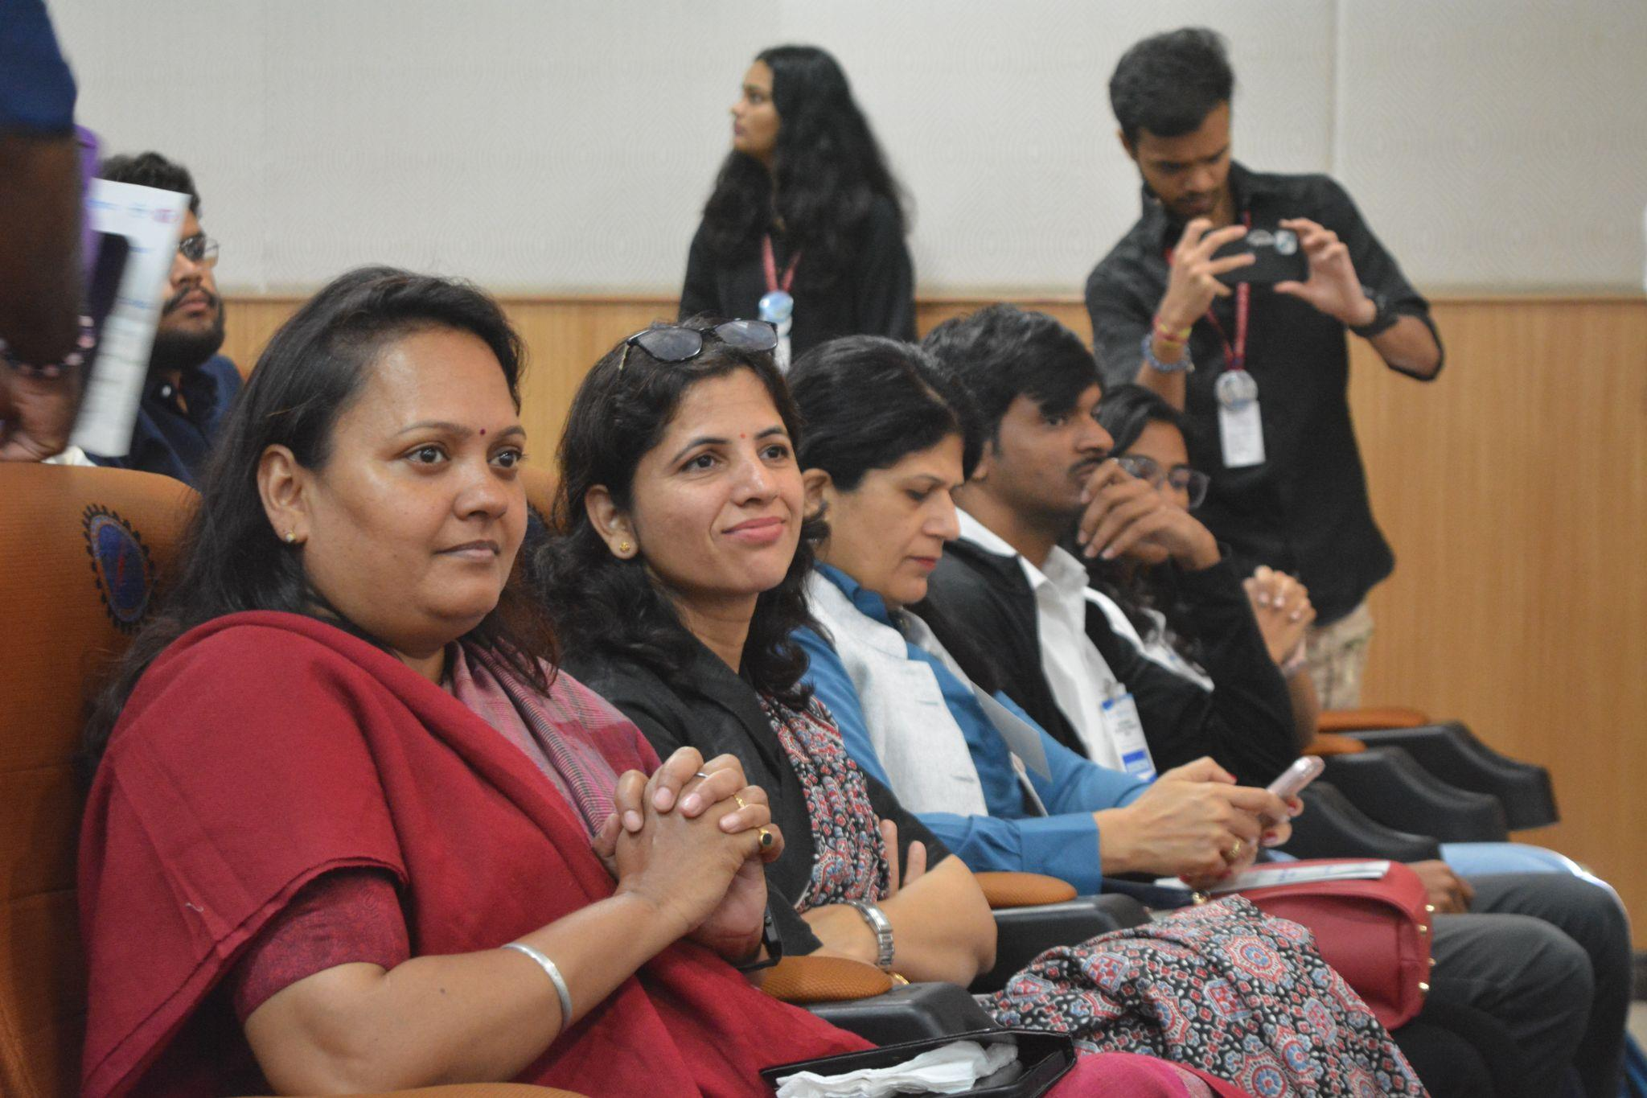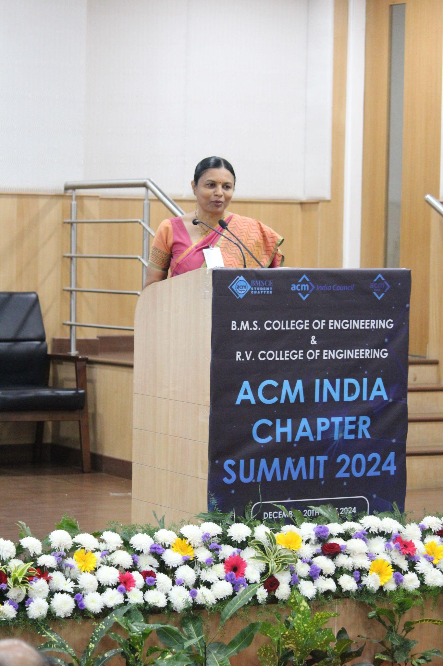

### **9:30 AM to 10:30 AM – Keynote 1: Sustainable AI – Challenges and Opportunities for the Future**

**Dr. Rama Govindaraju**, Senior Engineering Director at NVIDIA, United States, presented an enlightening keynote on **Sustainable AI**. The talk explored the challenges of designing energy-efficient AI systems and the opportunities they present for addressing global challenges. Dr. Rama provided examples of how AI technologies can be leveraged to meet sustainability goals, making the session both thought-provoking and inspiring.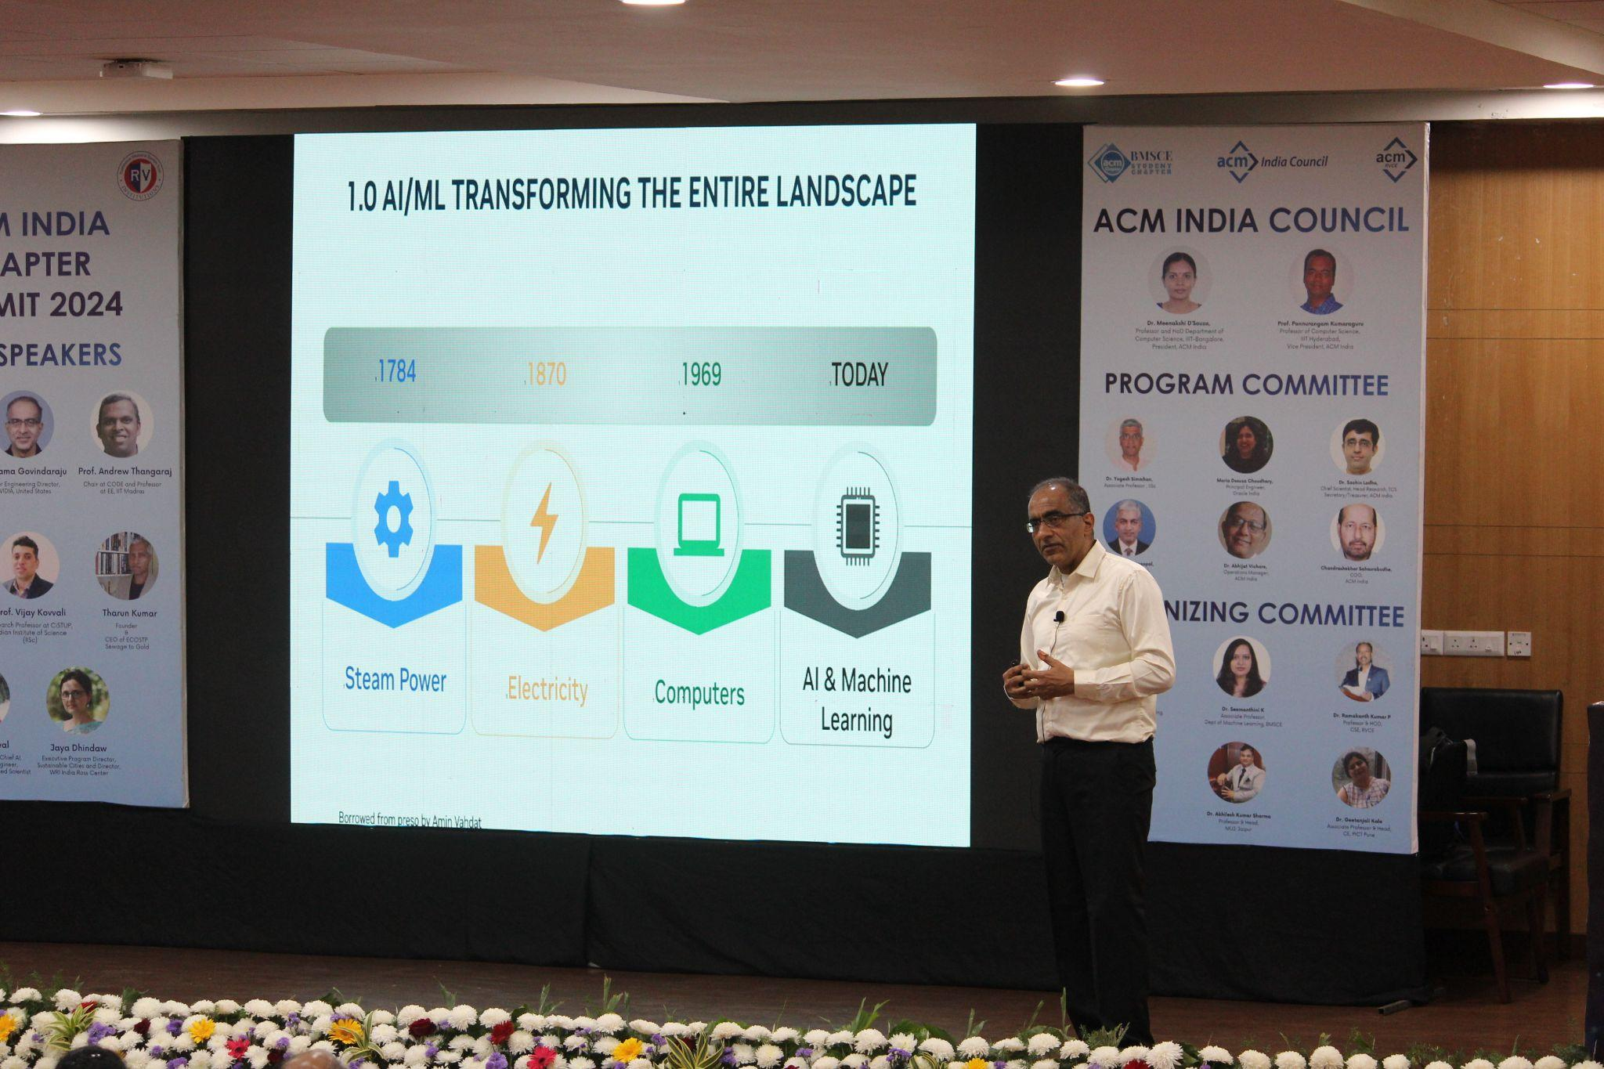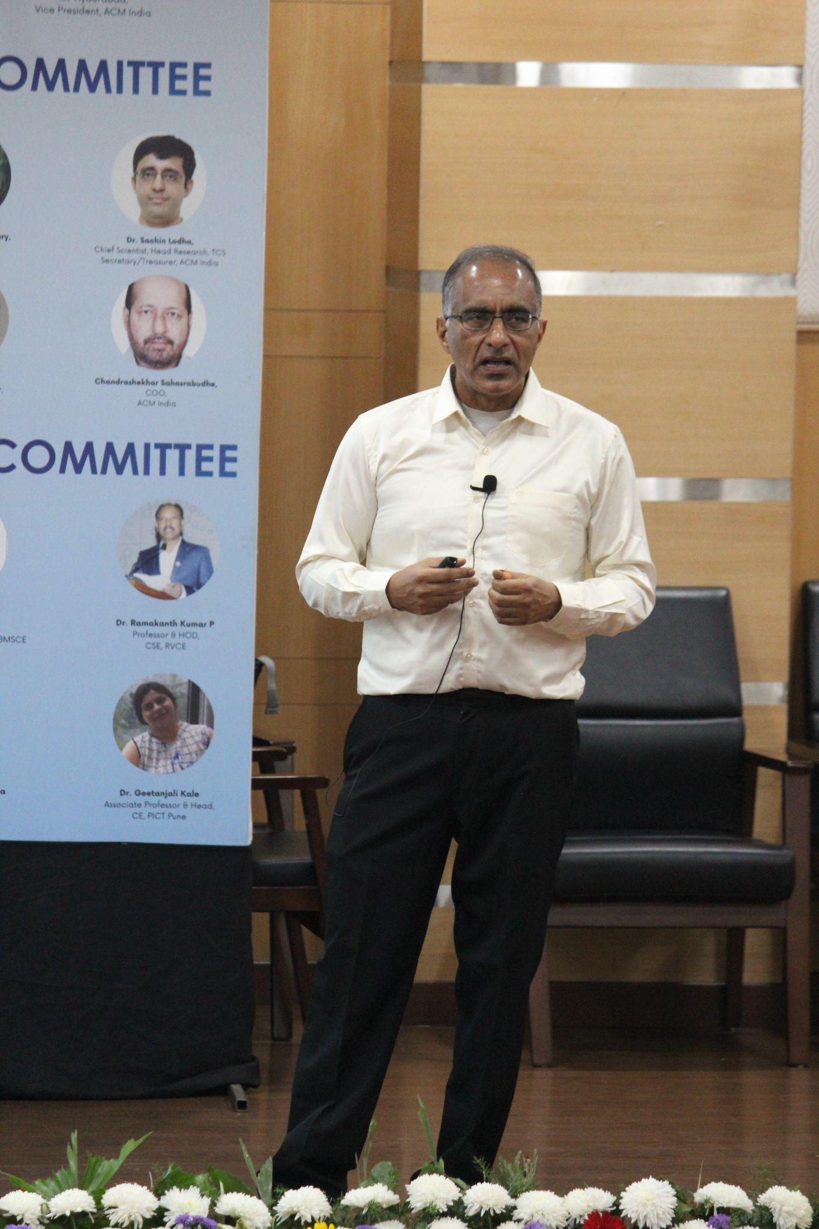

### **10:30 AM to 11:00 AM – Presentations by Award-winning Chapters**

This session was moderated by **Dr. Geetanjali Kale**, Associate Professor at PICT Pune, which showcased the accomplishments of award-winning ACM chapters:

1. **Emerging Chapter Award** – VIT ACM-W Student Chapter, Vellore
2. **Outstanding Recruitment Program Award** – KARE ACM Student Chapter, Madurai
3. **Outstanding Community Service Award** – AISSMS IOIT ACM Student Chapter, Pune
4. **Outstanding Chapter Activities Award** – PCCOE ACM Student Chapter, Pune
5. **Outstanding Chapter Website Award** – MUJ ACM SIGBED Student Chapter, Jaipur
6. **Outstanding Chapter Award** – UPES ACM-W Student Chapter, Dehradun

Each chapter shared innovative practices and initiatives that led to their recognition, inspiring other participants to emulate their success.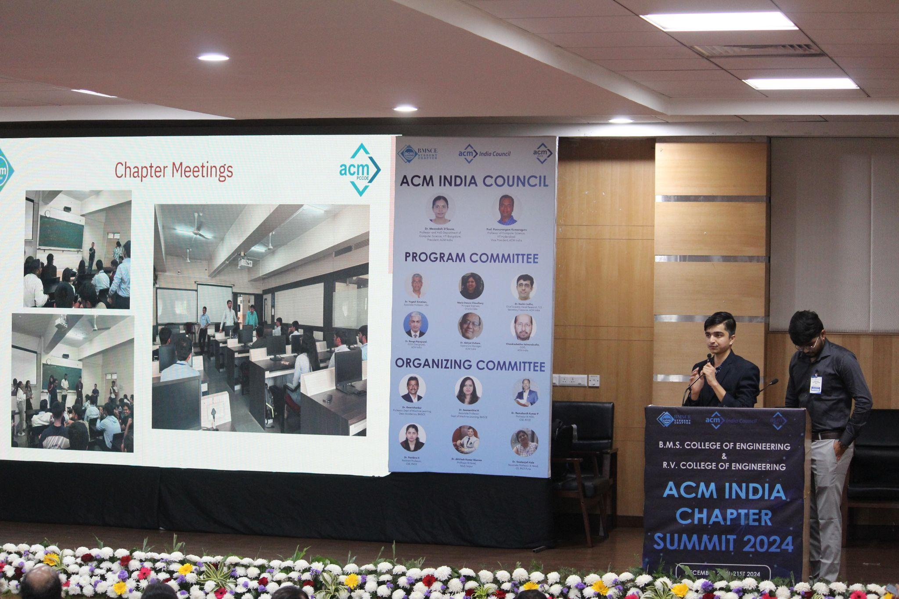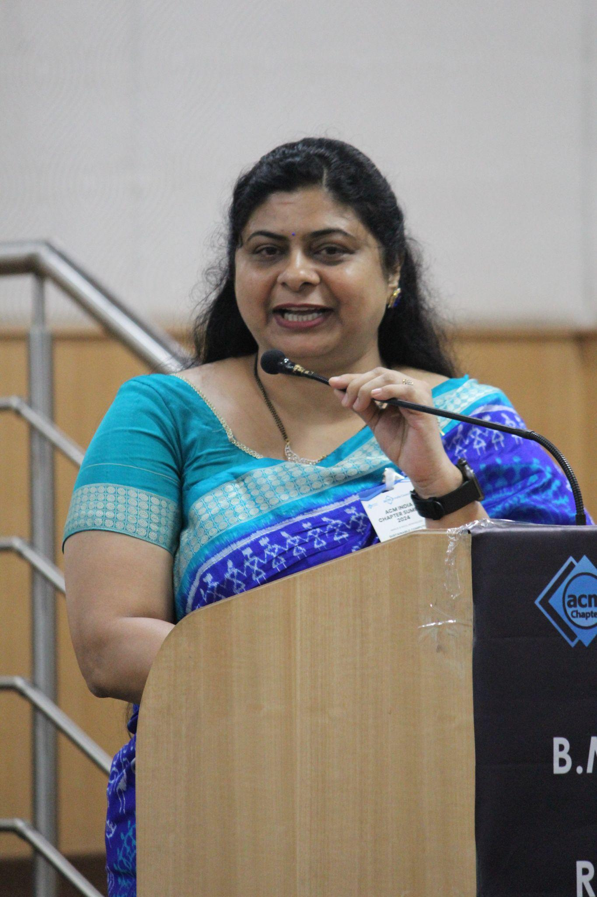

### **11:00 AM to 11:15 AM – Portal Presentation**

**Dr. Sagar Juneja**, Associate Director (Research) at Chitkara University, introduced the **ESP Portal**, a streamlined solution for managing the ACM India **Eminent Speaker Program**. Key features included modules for student chapters and **ACM India Portal**.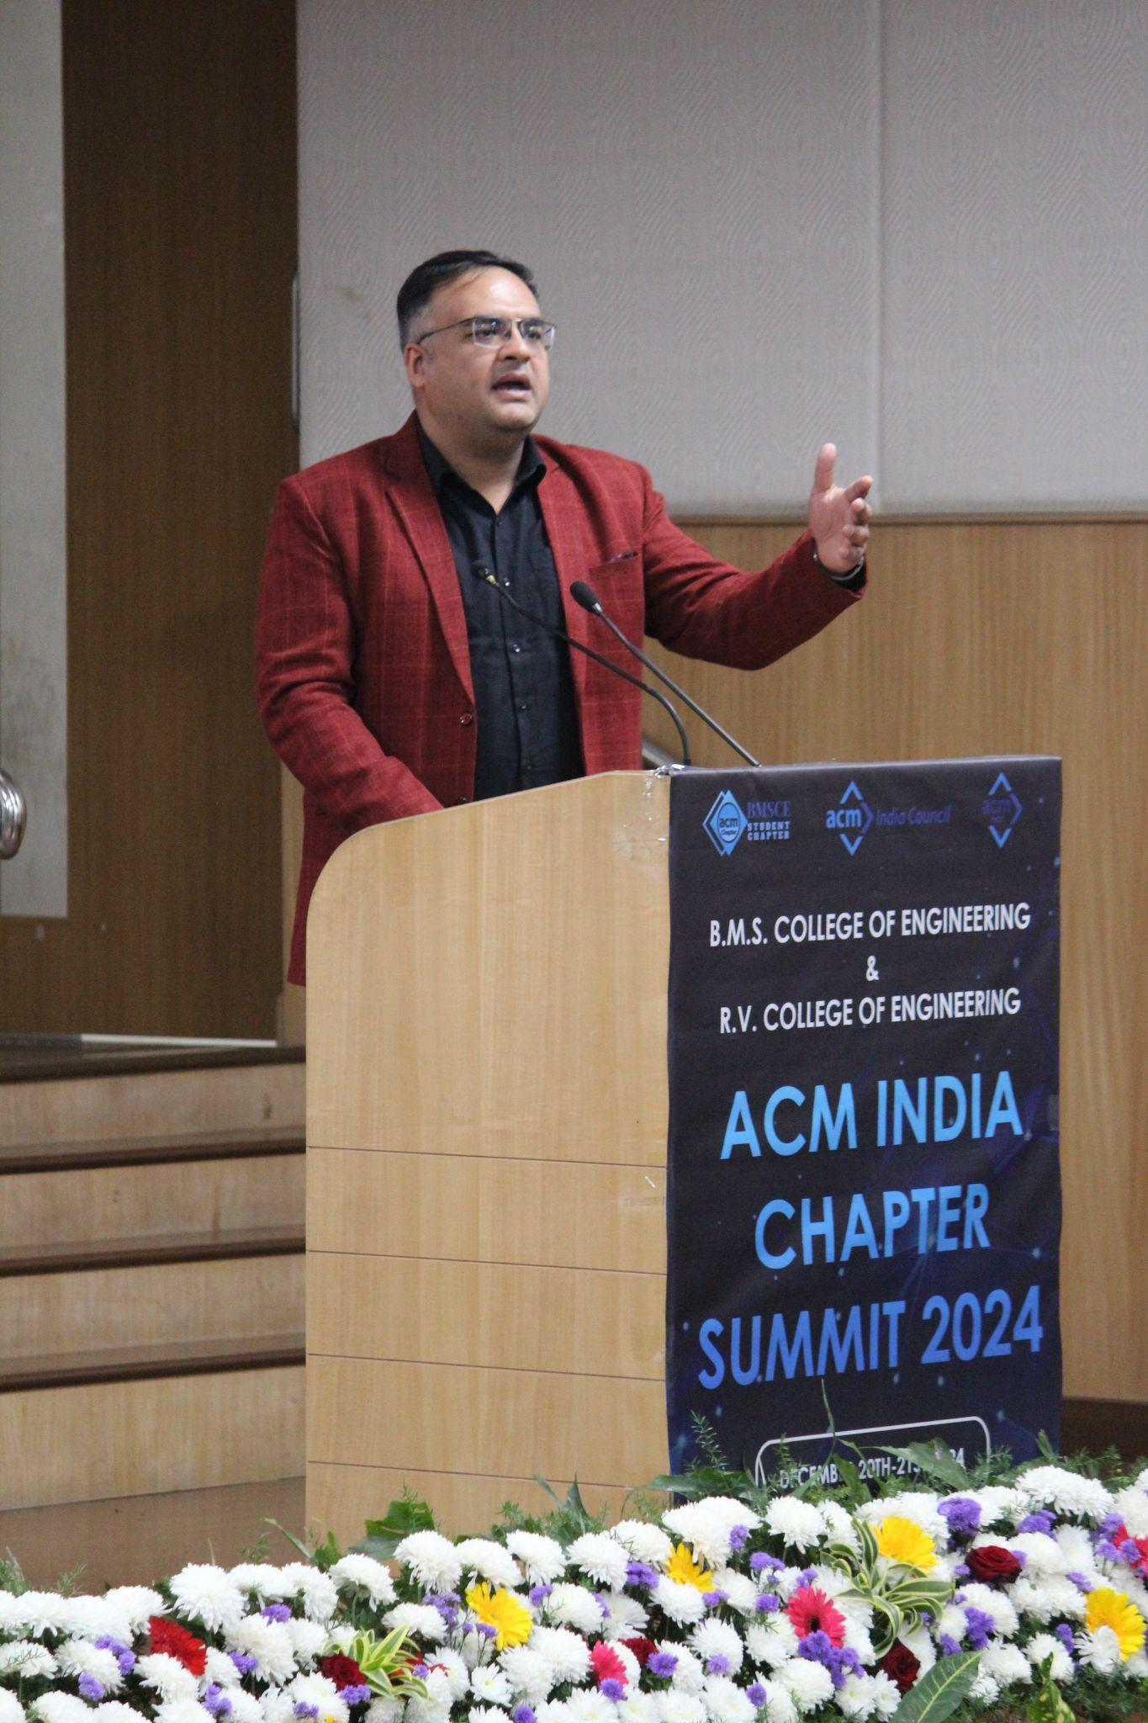

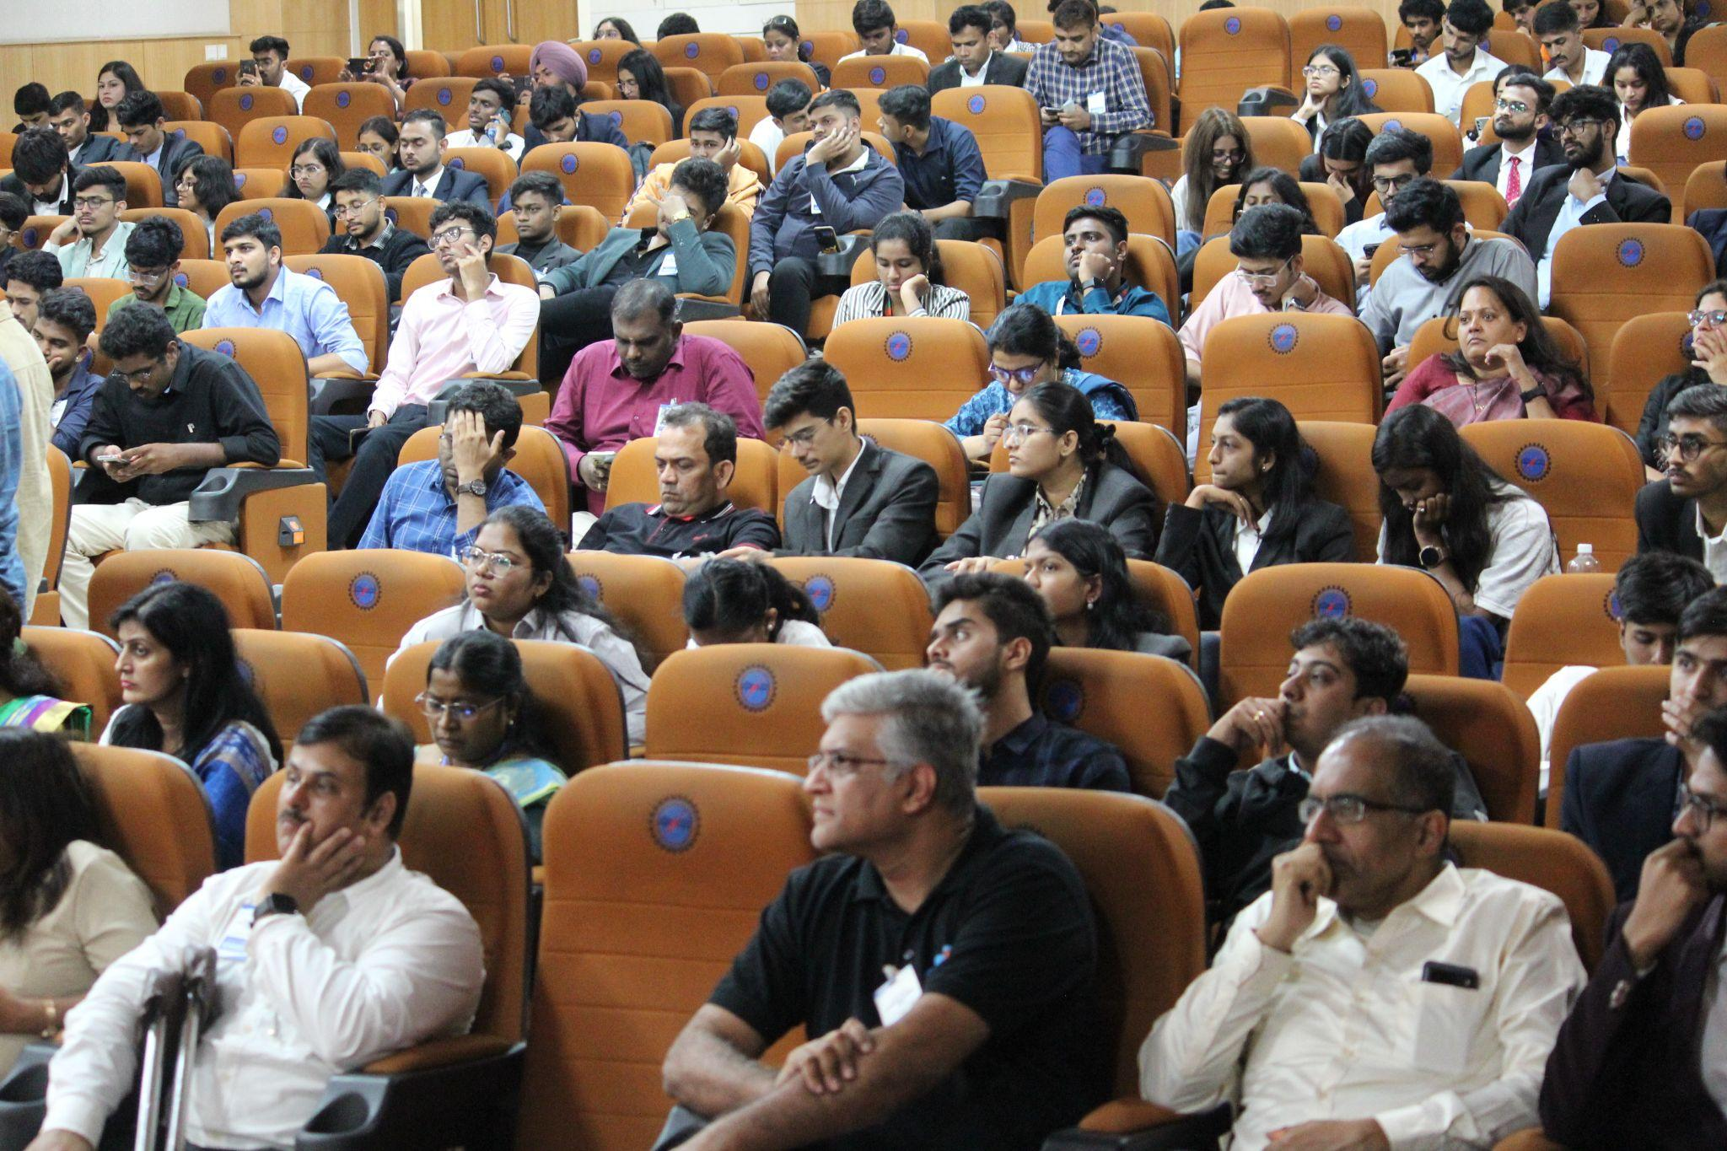

### **11:15 AM to 11:20 AM – Inauguration & Welcome by BMSCE**

The summit was formally inaugurated by the dignitaries present in the Summit with a traditional **lamp-lighting ceremony**. They welcomed participants, expressed gratitude to the ACM India Council, and reiterated their commitment to the summit’s success.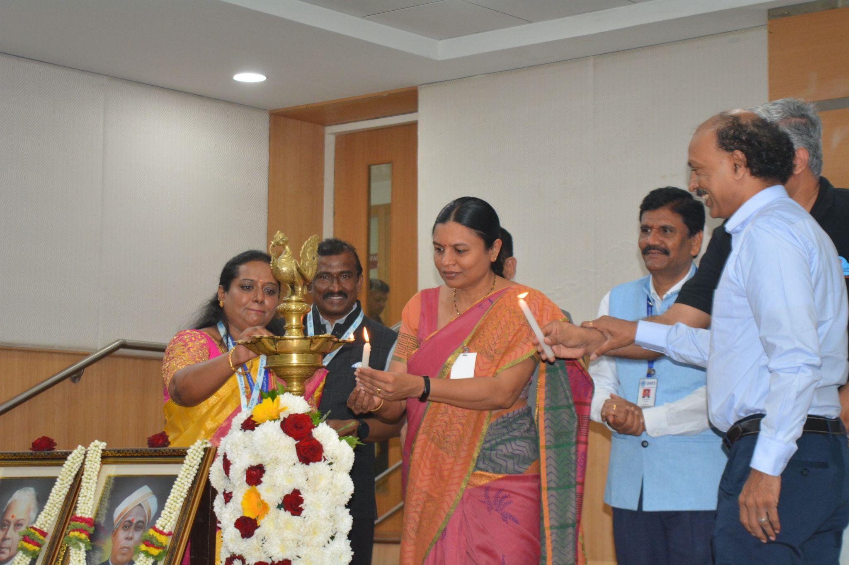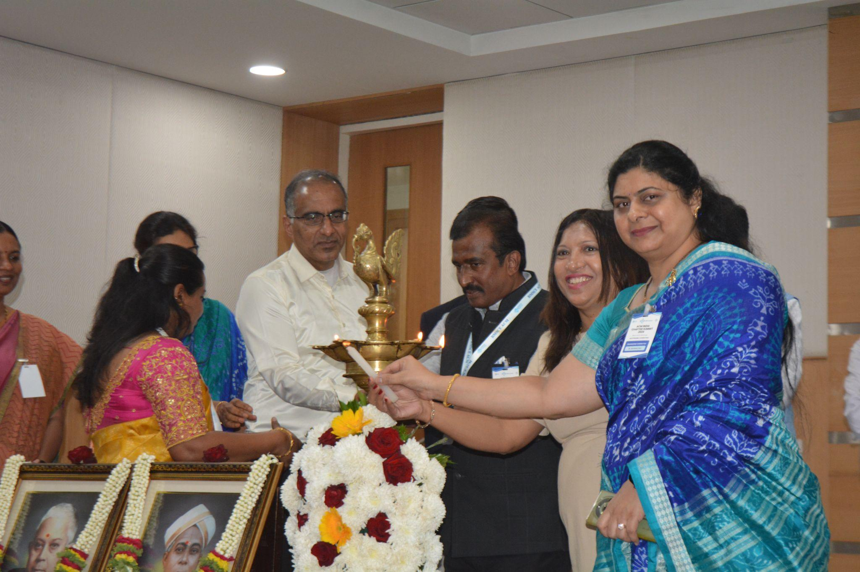

### **11:20 AM to 11:45 AM – Tea Break and Networking**

Participants enjoyed a refreshing tea break while networking with peers, speakers, and ACM representatives. This informal setting fostered meaningful connections and lively conversations.

### **11:45 AM to 12:00 PM – Report on Previous Year’s Summit**

**Dr. Akhilesh Kumar Sharma**, Professor & Head, MUJ, Jaipur, who was the organizer of the previous year’s summit, presented an overview of the 2023 ACM India Chapter Summit. He detailed key achievements, objectives of engagement committees, and actions implemented from the previous summit.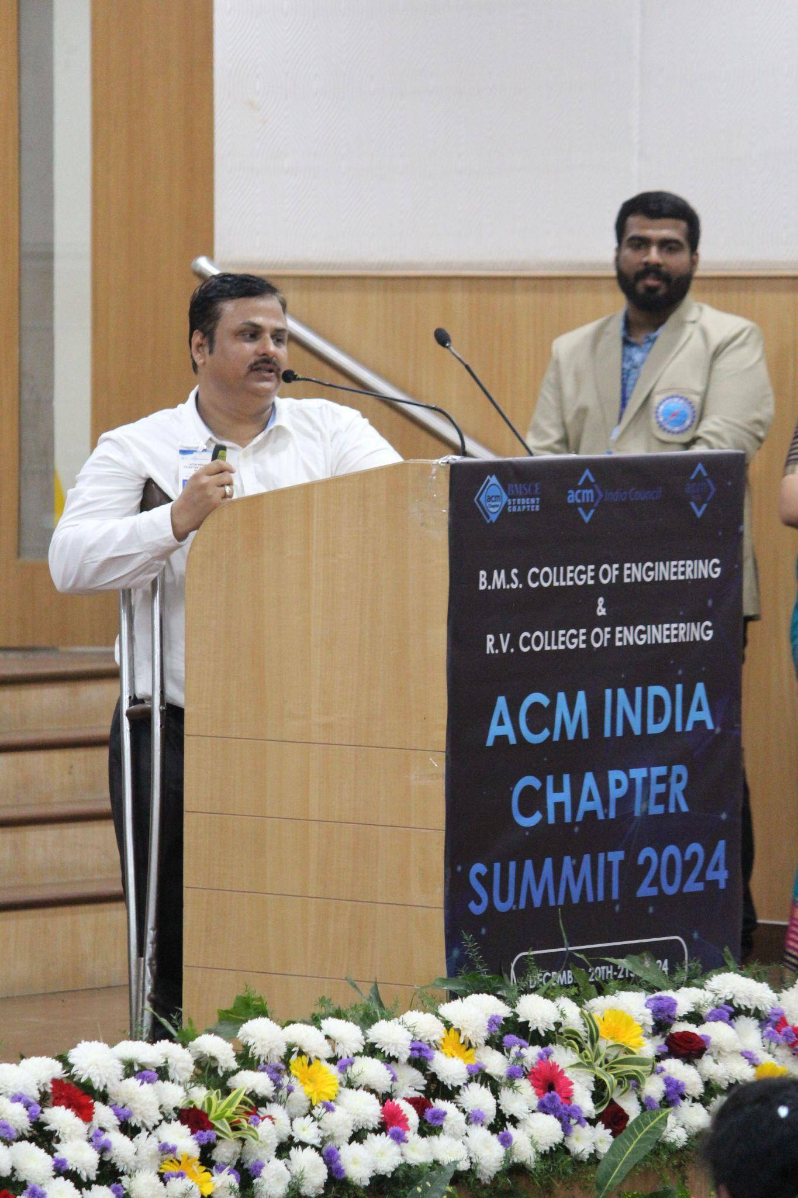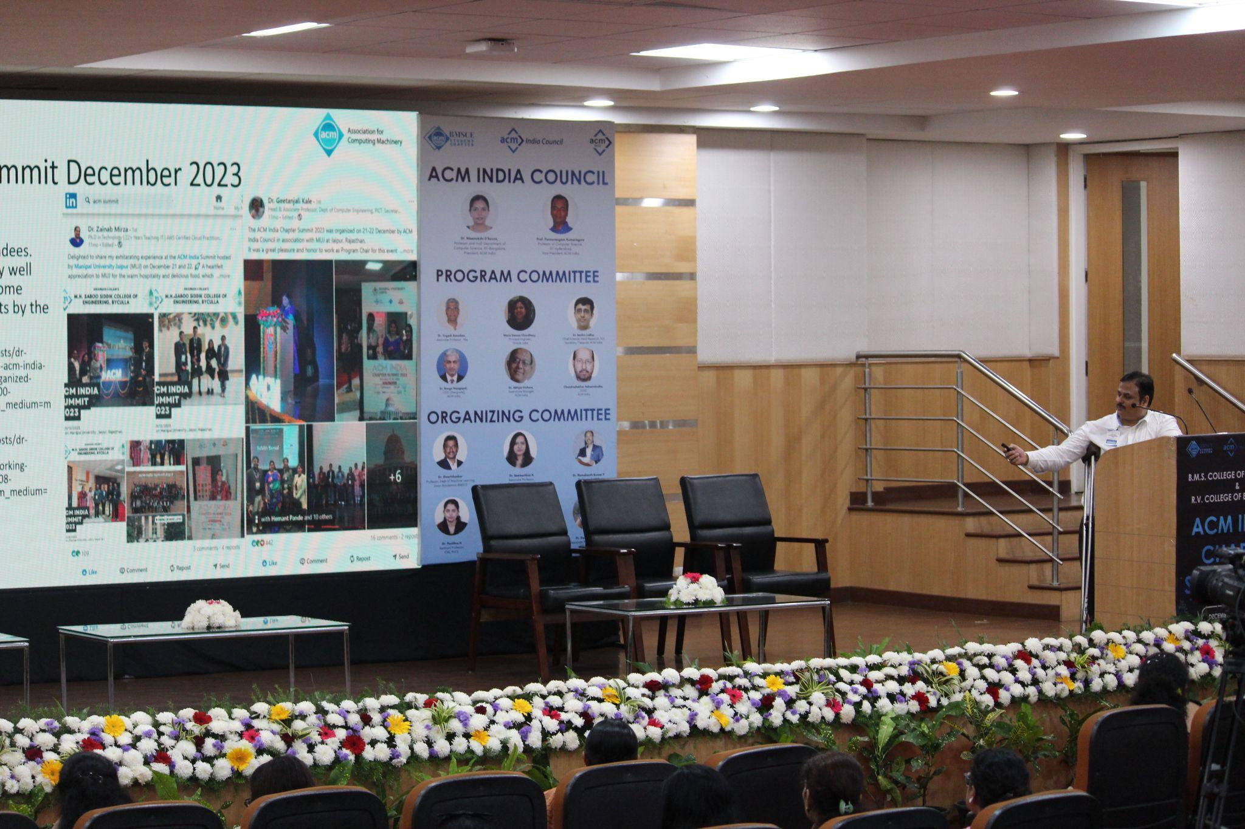

### **12:20 PM to 1:00 PM – Ask Me Anything Session**

An interactive session led by Dr. Meenakshi D’Souza, Dr. Yogesh Simmhan, Ms. Maria Dsouza Choudhary, Dr. Akhilesh Kumar Sharma, Dr. Ranga Rajagopal, and Dr. Geetanjali Kale allowed participants to ask questions about ACM initiatives and technical topics. They also emphasized on the opportunities provided by ACM India that included ROCS, Activity Based Funding, Eminent Speaker Program, Distinguished Speaker Program.

Participants also discussed opportunities for chapter collaborations, criteria to secure funding, and methods for fostering growth within ACM student chapters. Questions about ACM India's summer and winter schools, their mentorship programs, and the range of opportunities available for students and educators were addressed, offering valuable insights into maximizing benefits from ACM initiatives. 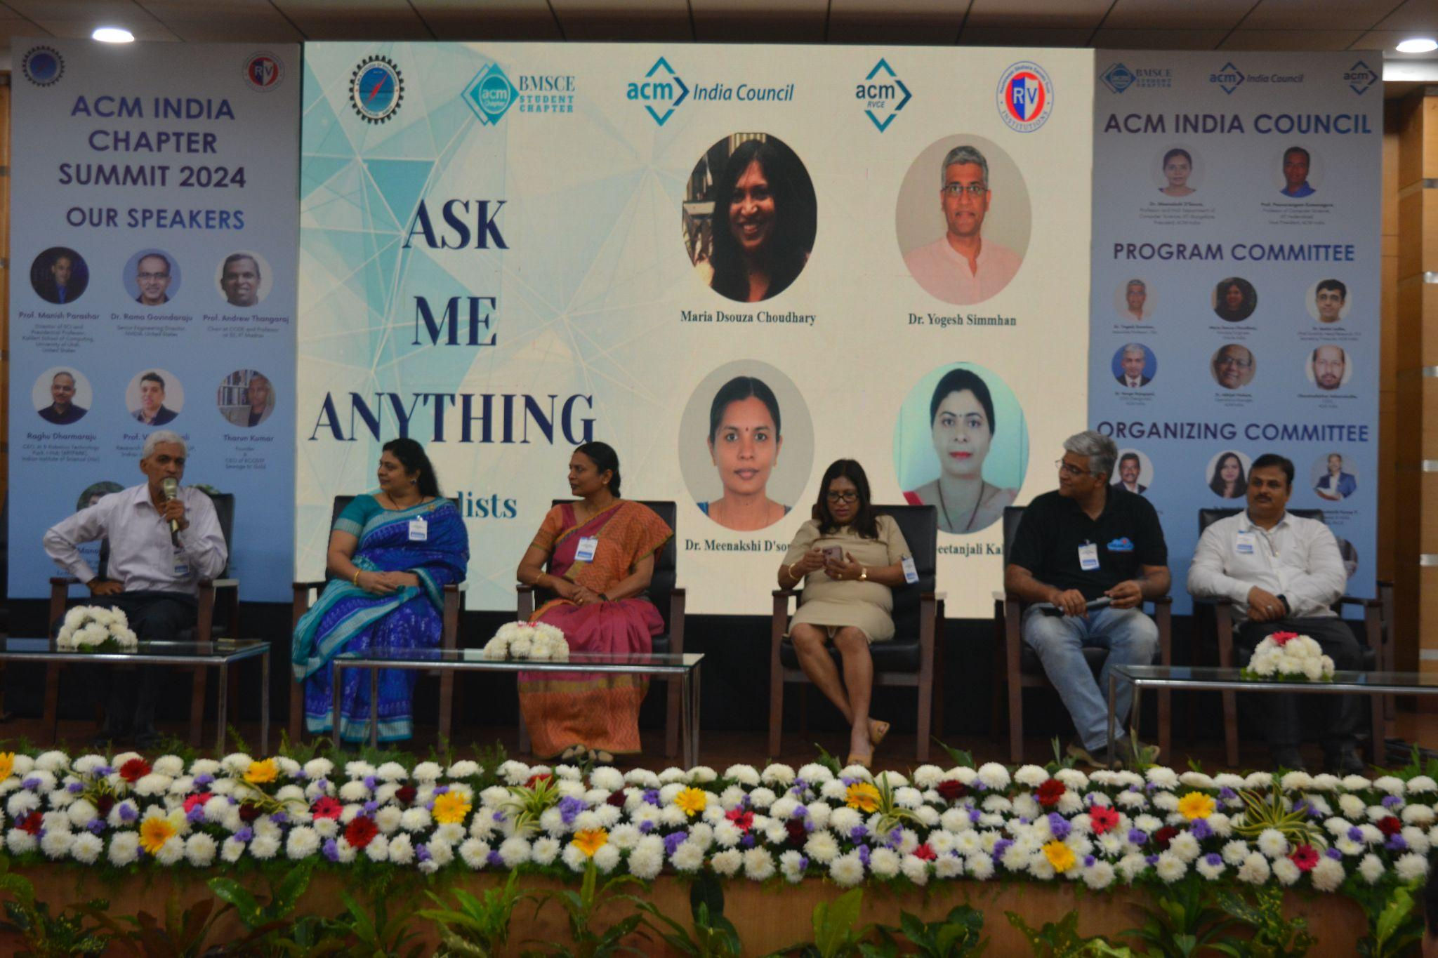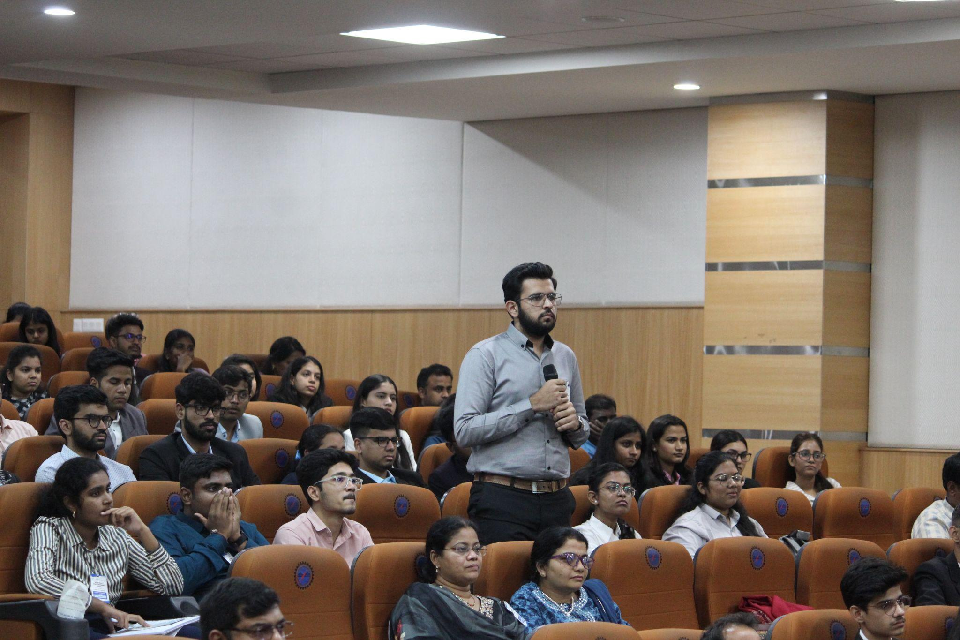

### **1:00 PM to 2:00 PM – Lunch & Networking**

Attendees gathered for a delicious lunch, providing another opportunity for informal networking and exchanging ideas with fellow participants.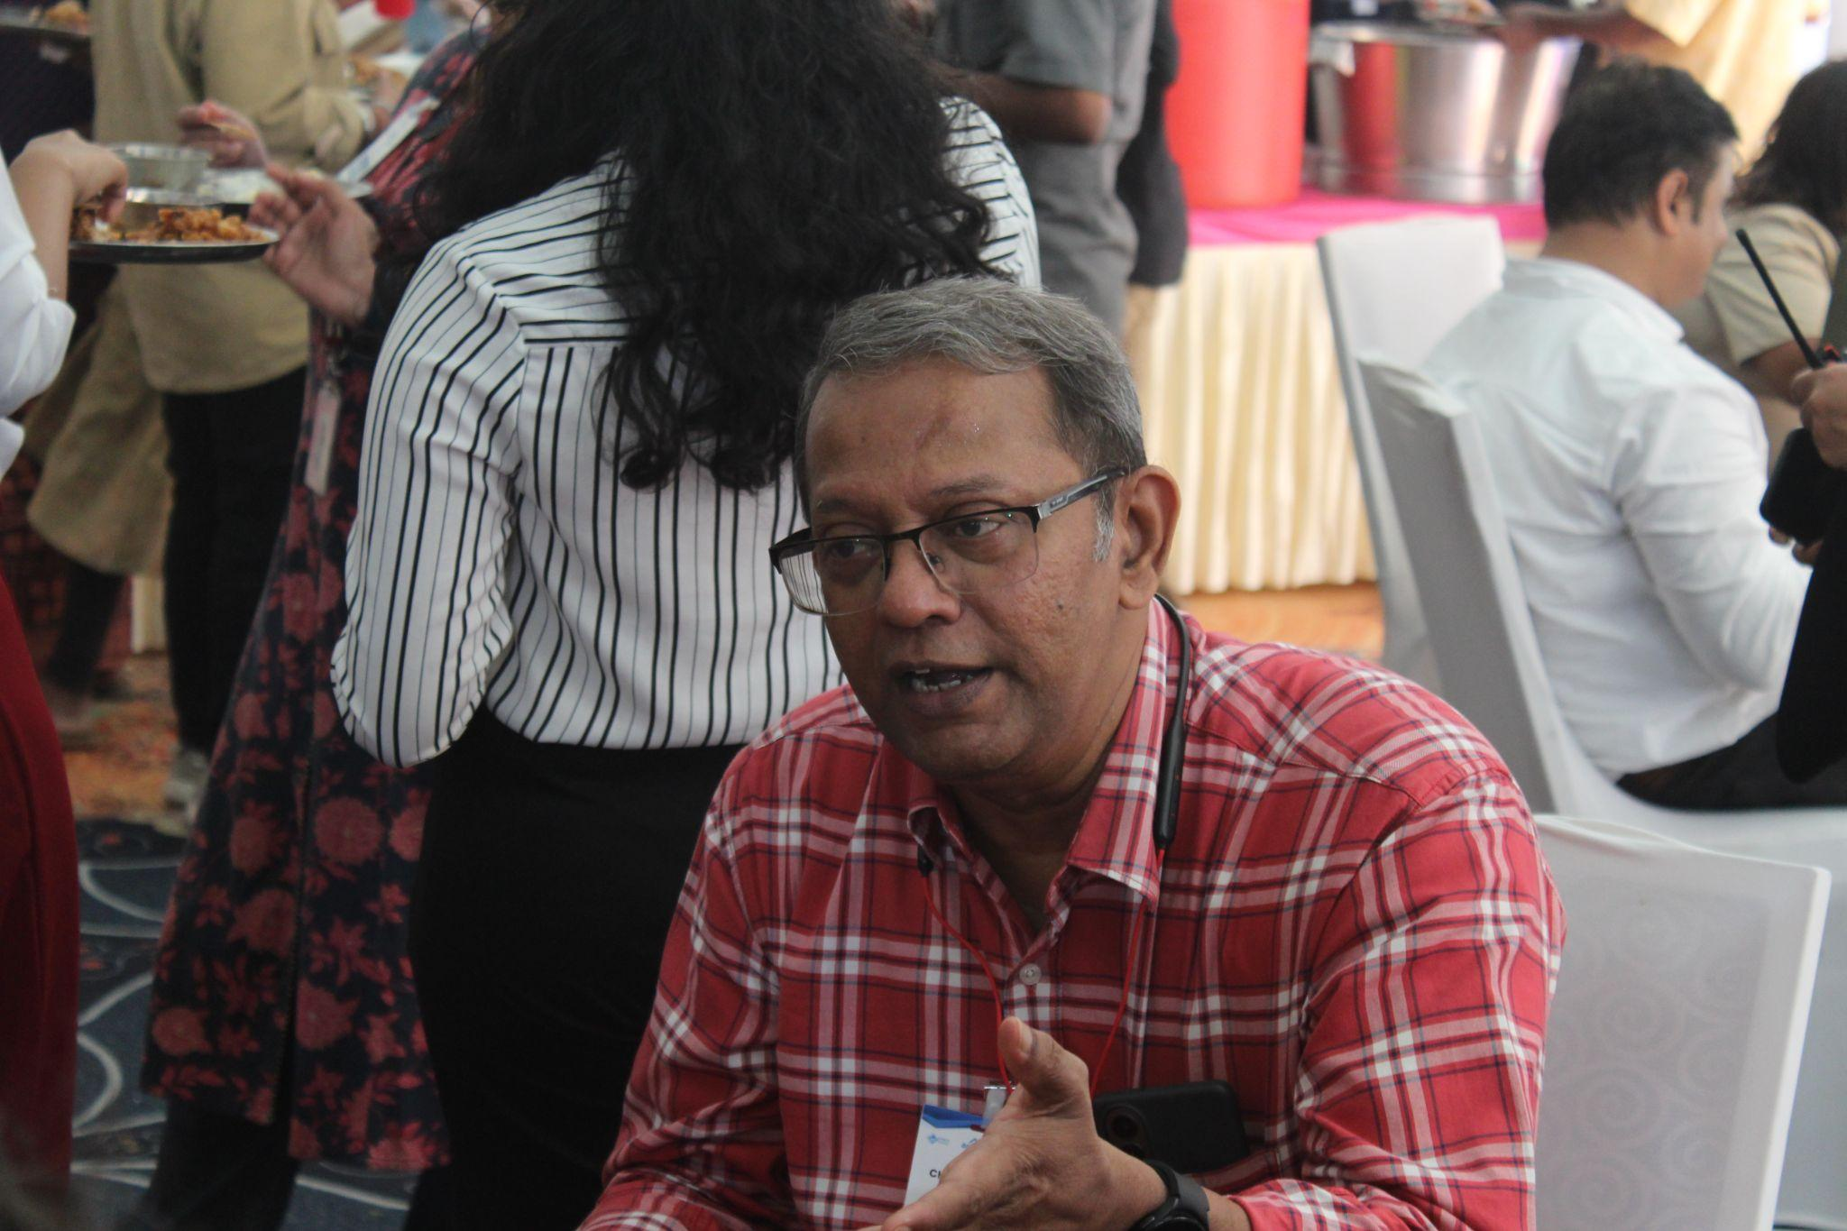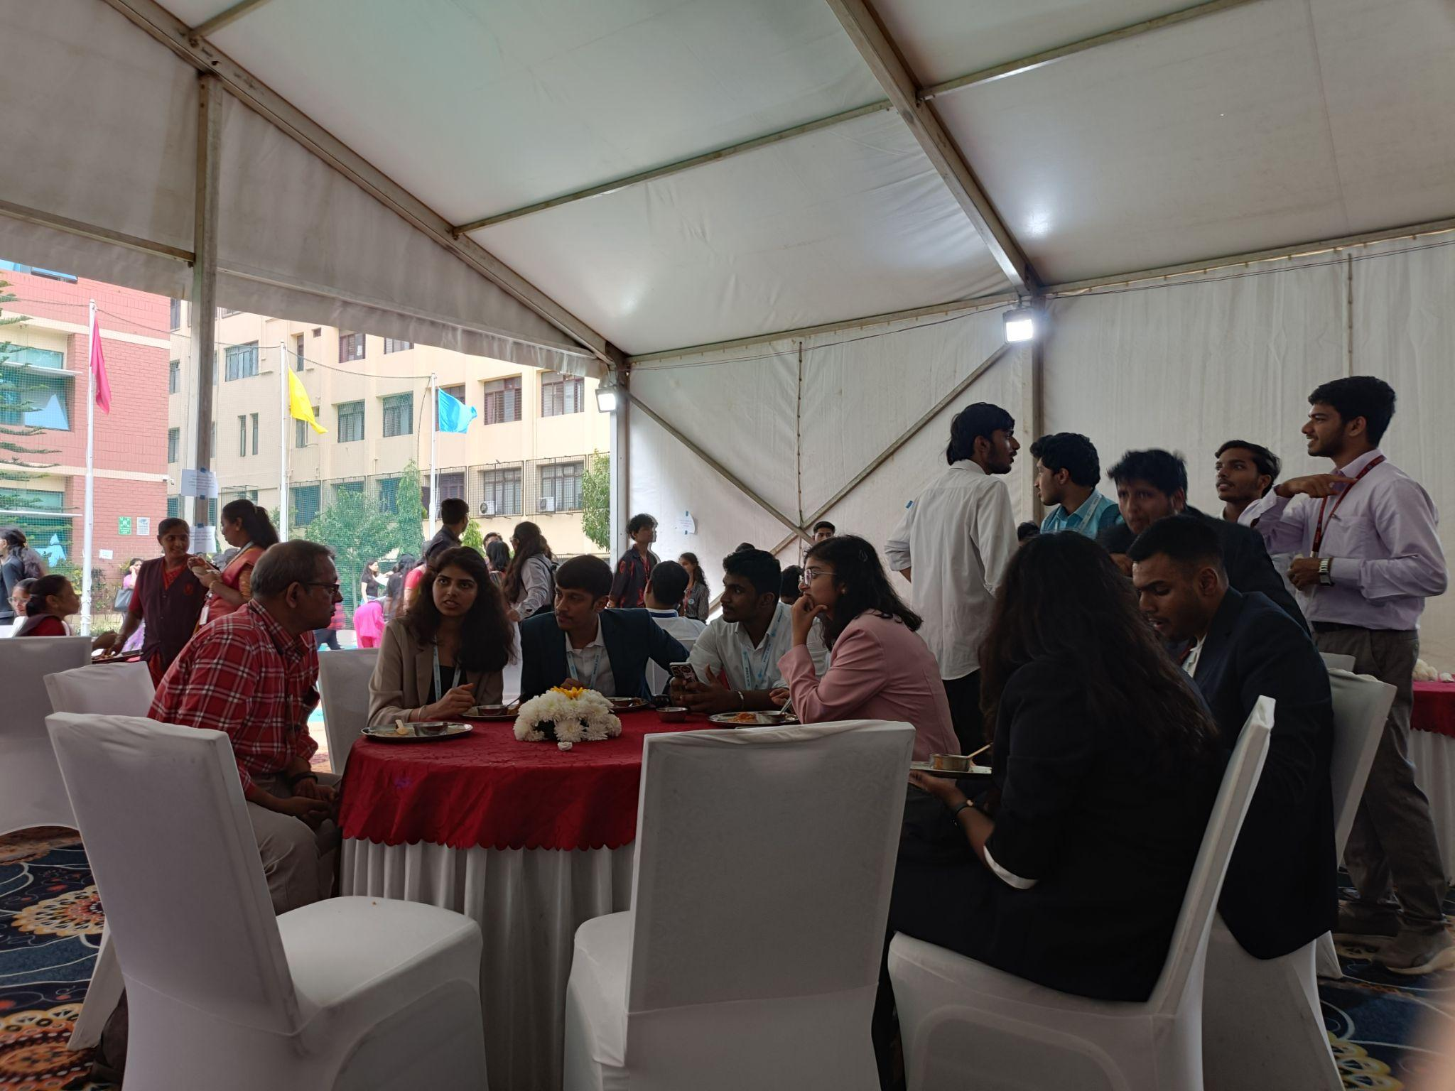

### **2:00 PM to 3:00 PM – Transport to RV College of Engineering(RVCE)**

Participants traveled to RVCE for the afternoon sessions, transitioning seamlessly between venues.

### **3:00 PM to 3:30 PM – Poster Setup**

Participants prepared their posters for the upcoming presentation and competition, arranging them in a dedicated exhibition space at RVCE.

### **3:30 PM to 4:30 PM – Technical Session: Technology for Sustainability**

**Prof. Vijay Kovvali**, Research Professor at CiSTUP, Indian Institute of Science(IISC) and **Jaya Dhindaw,** Executive Program Director, Sustainable Cities and Director, WRI India Ross Center, led a compelling session on using technology to achieve sustainability. They discussed cutting-edge innovations in urban planning, renewable energy, and green computing, providing actionable insights for participants.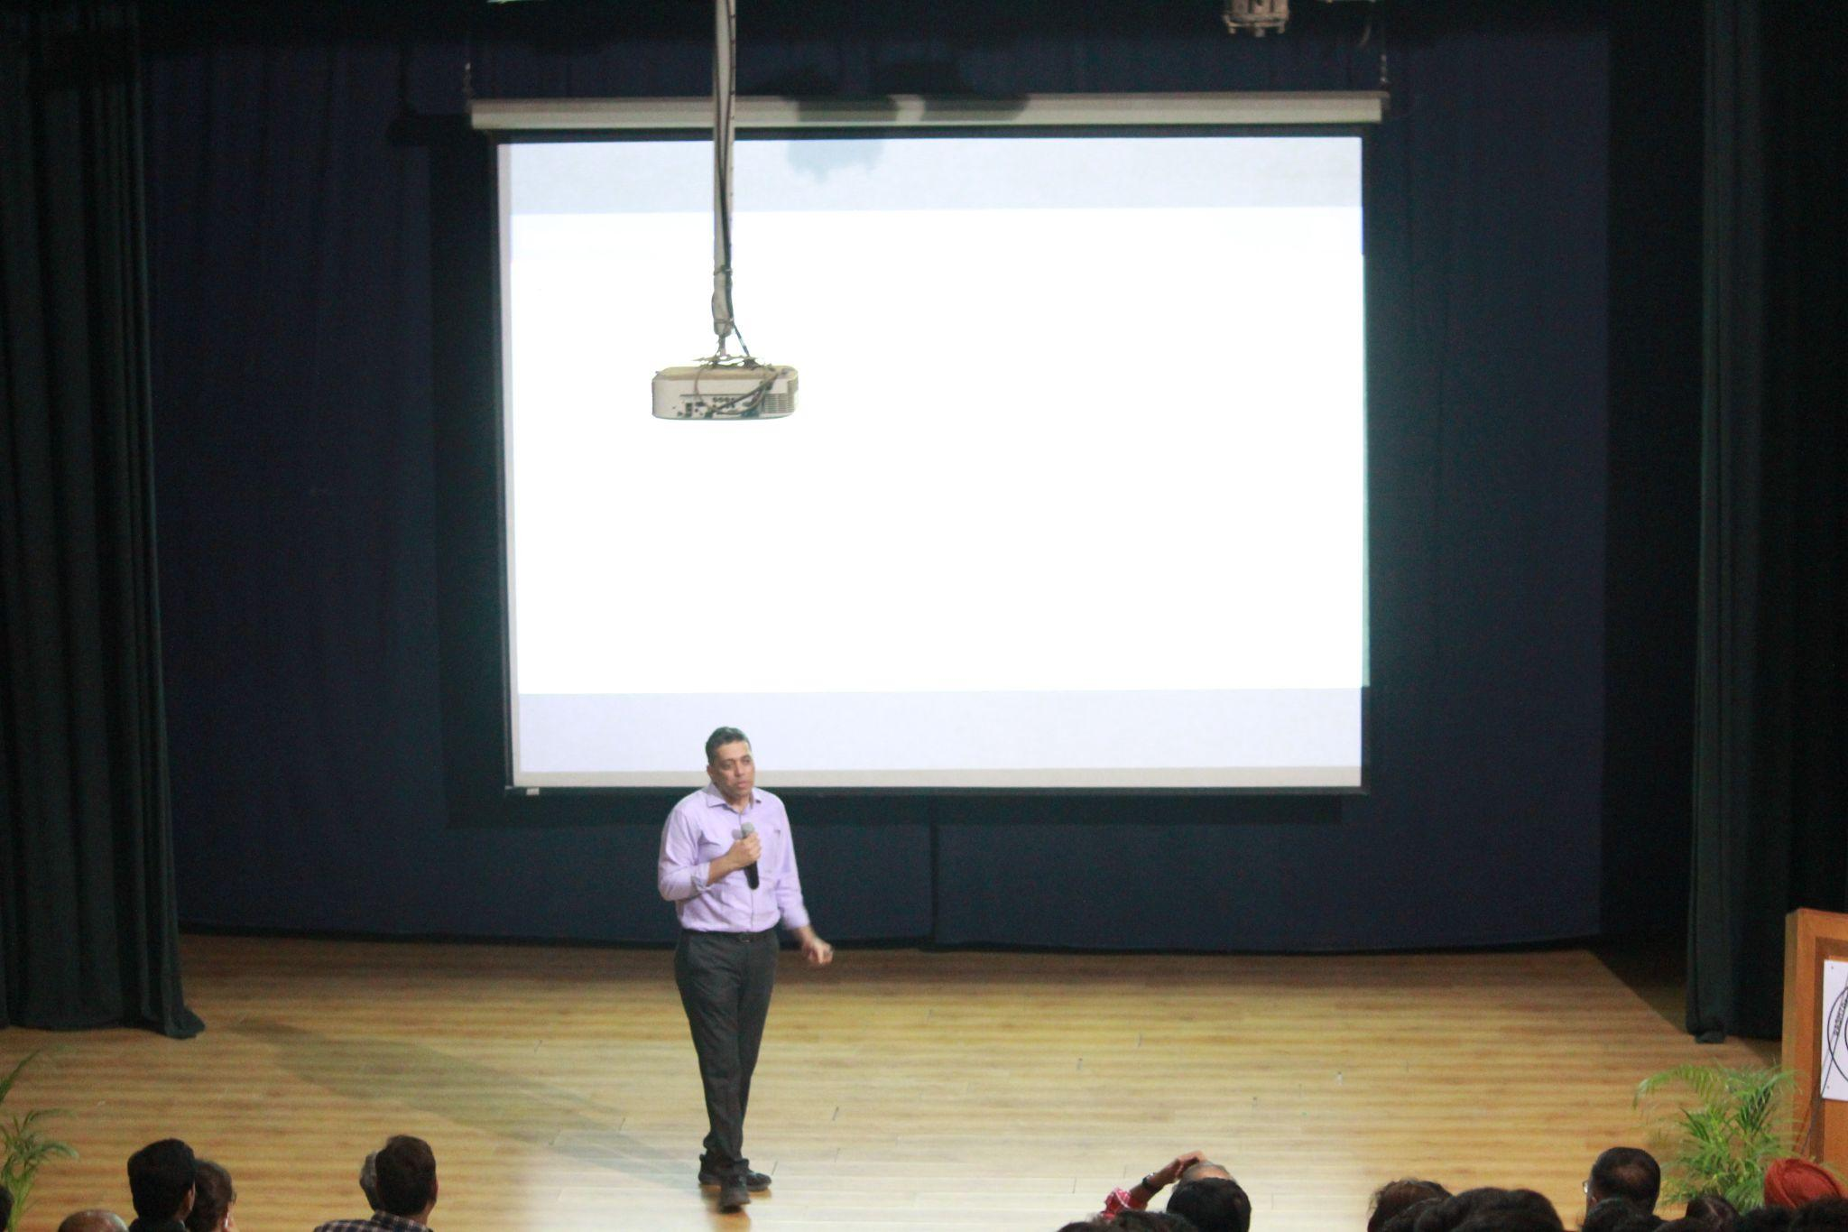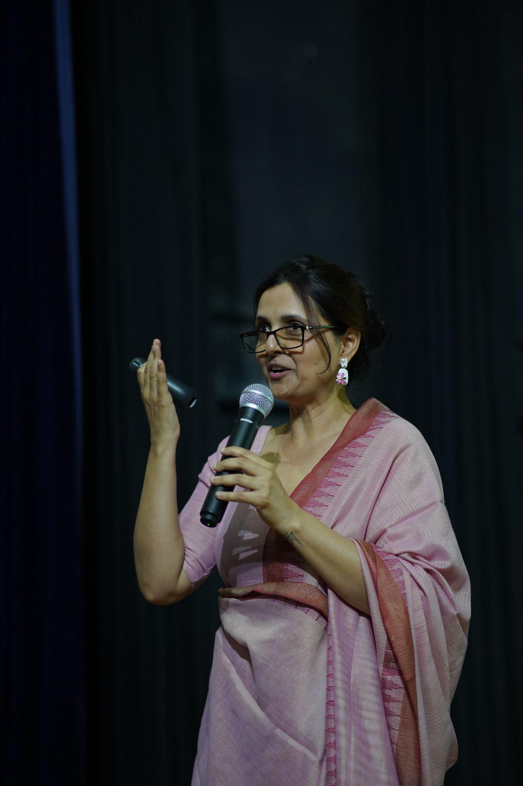

### **4:30 PM to 5:00 PM – Tea & Snacks Break**

Participants re-energized with light refreshments, engaging in informal discussions before the final sessions of the day.

### **5:00 PM to 6:00 PM – Poster Presentation and Competition**

Participants presented posters on the theme **“Imagining India in 2030: Pathways to Meet Sustainability Development Goals (SDG)”**. Judges evaluated the posters on creativity, research depth, and relevance, while the audience admired the diverse ideas presented.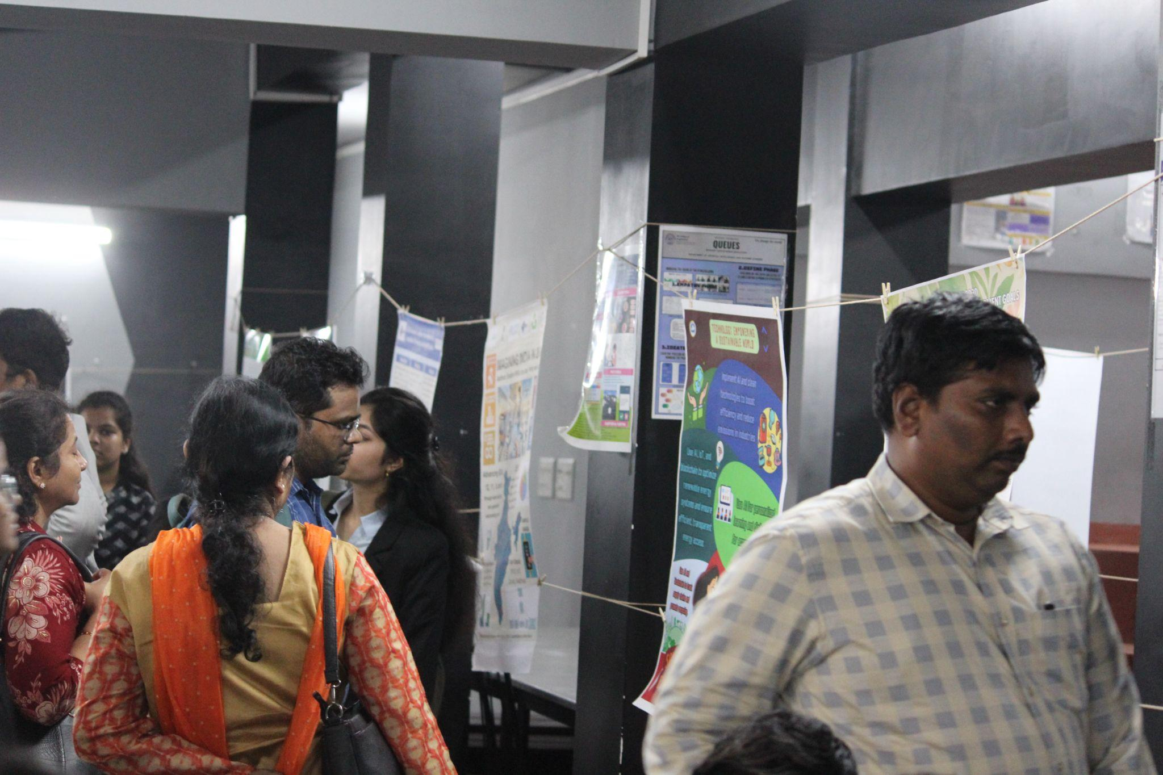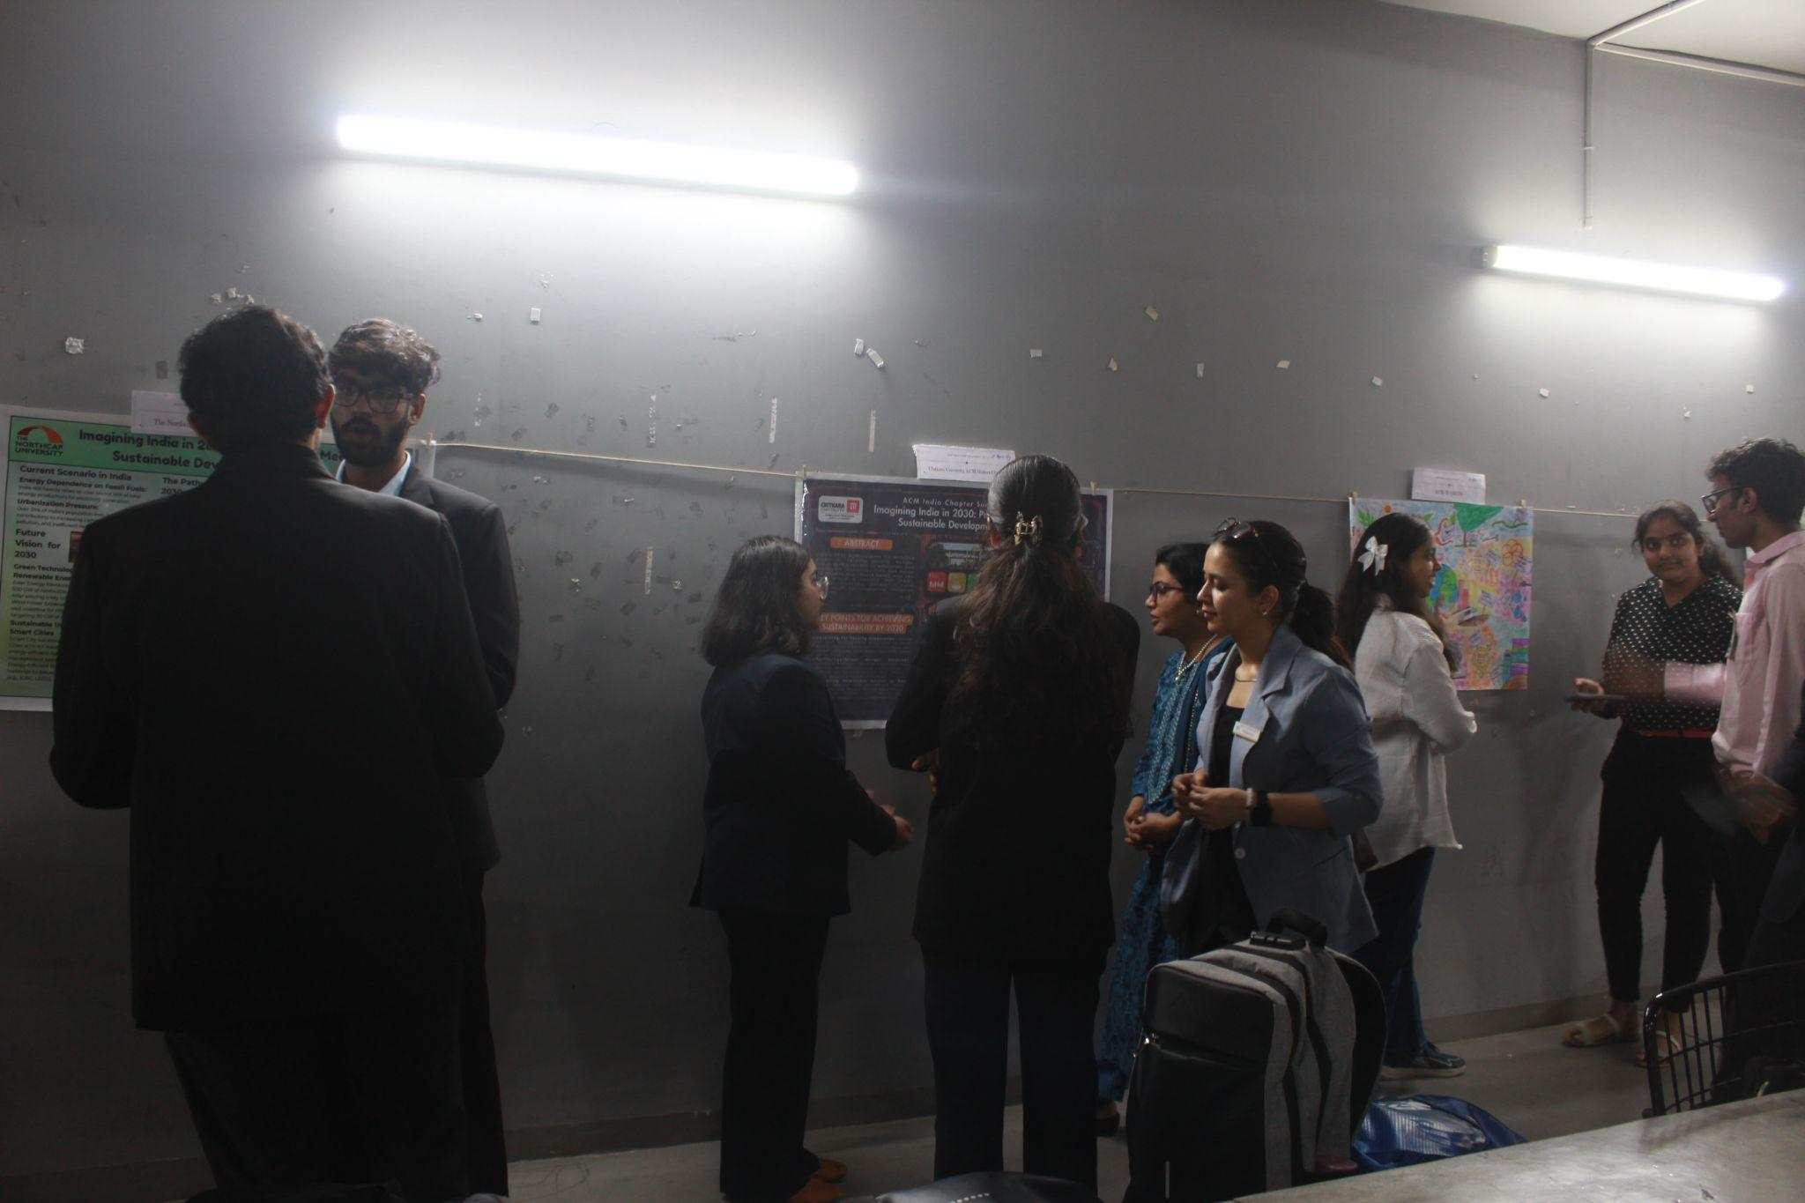

### **6:00 PM to 8:30 PM – Cultural Activities & Gala Dinner**

The day concluded with cultural performances by BMSCE Paramvah Team and RVCE Music band Dastaan and Music club Alaap showcasing the vibrant traditions of India. This was followed by a **gala dinner**, where participants reflected on the day’s highlights while enjoying an elaborate spread of delicacies.

After the conclusion of the day’s sessions, transportation was arranged to ensure participants returned to their respective accommodations comfortably and efficiently, providing them with an opportunity to rest and prepare for the upcoming activities.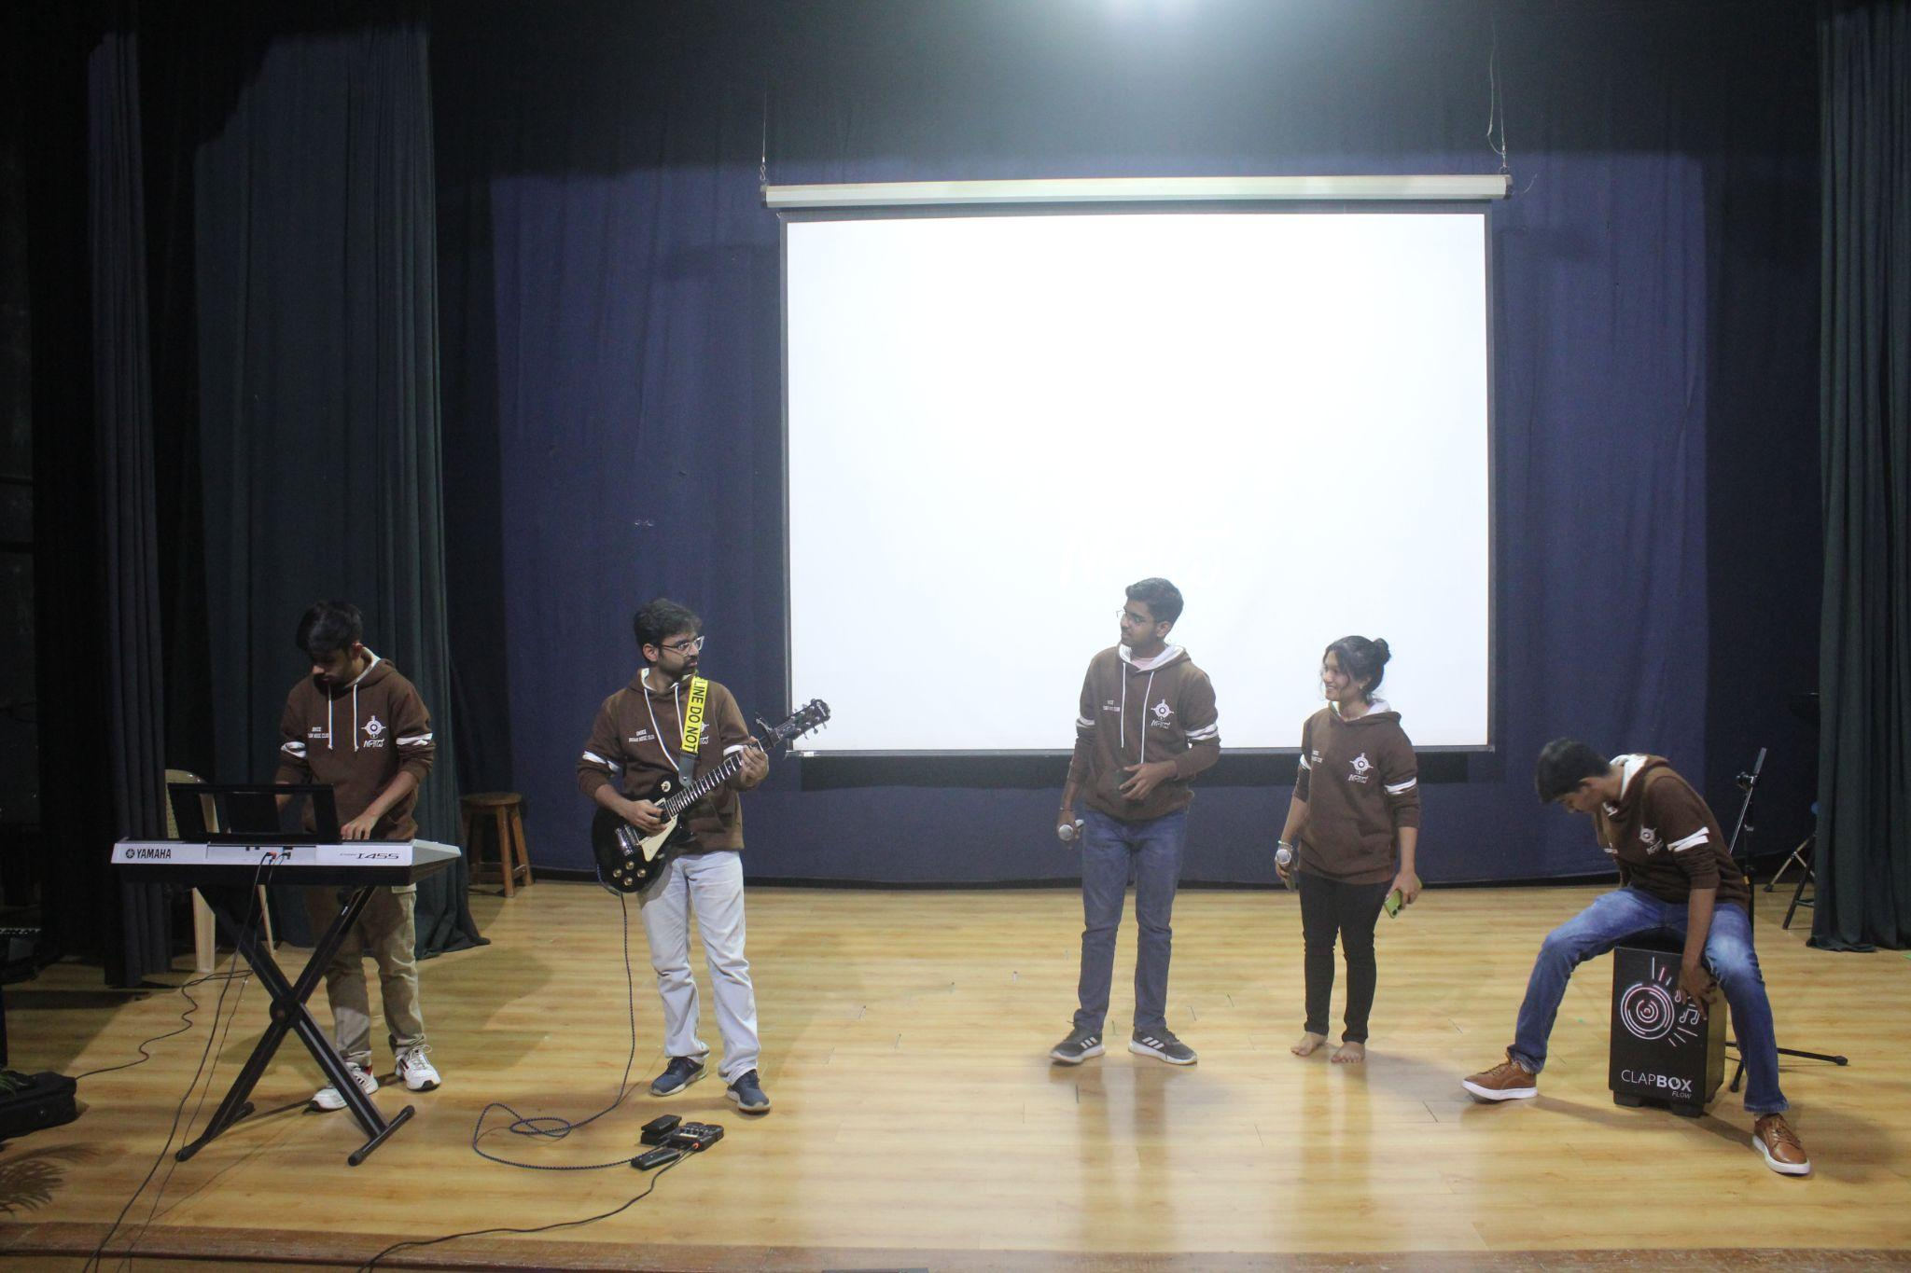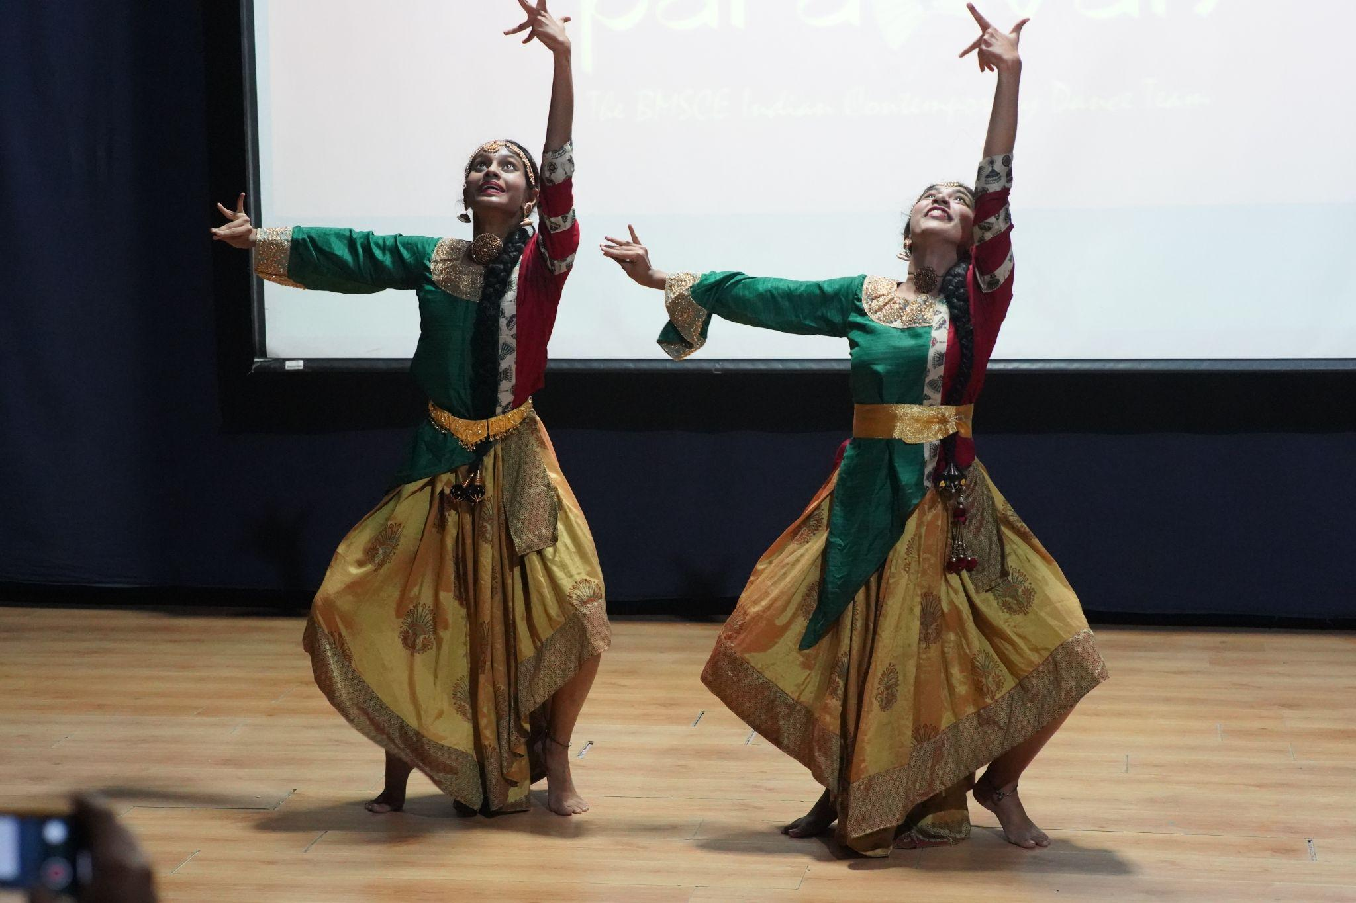

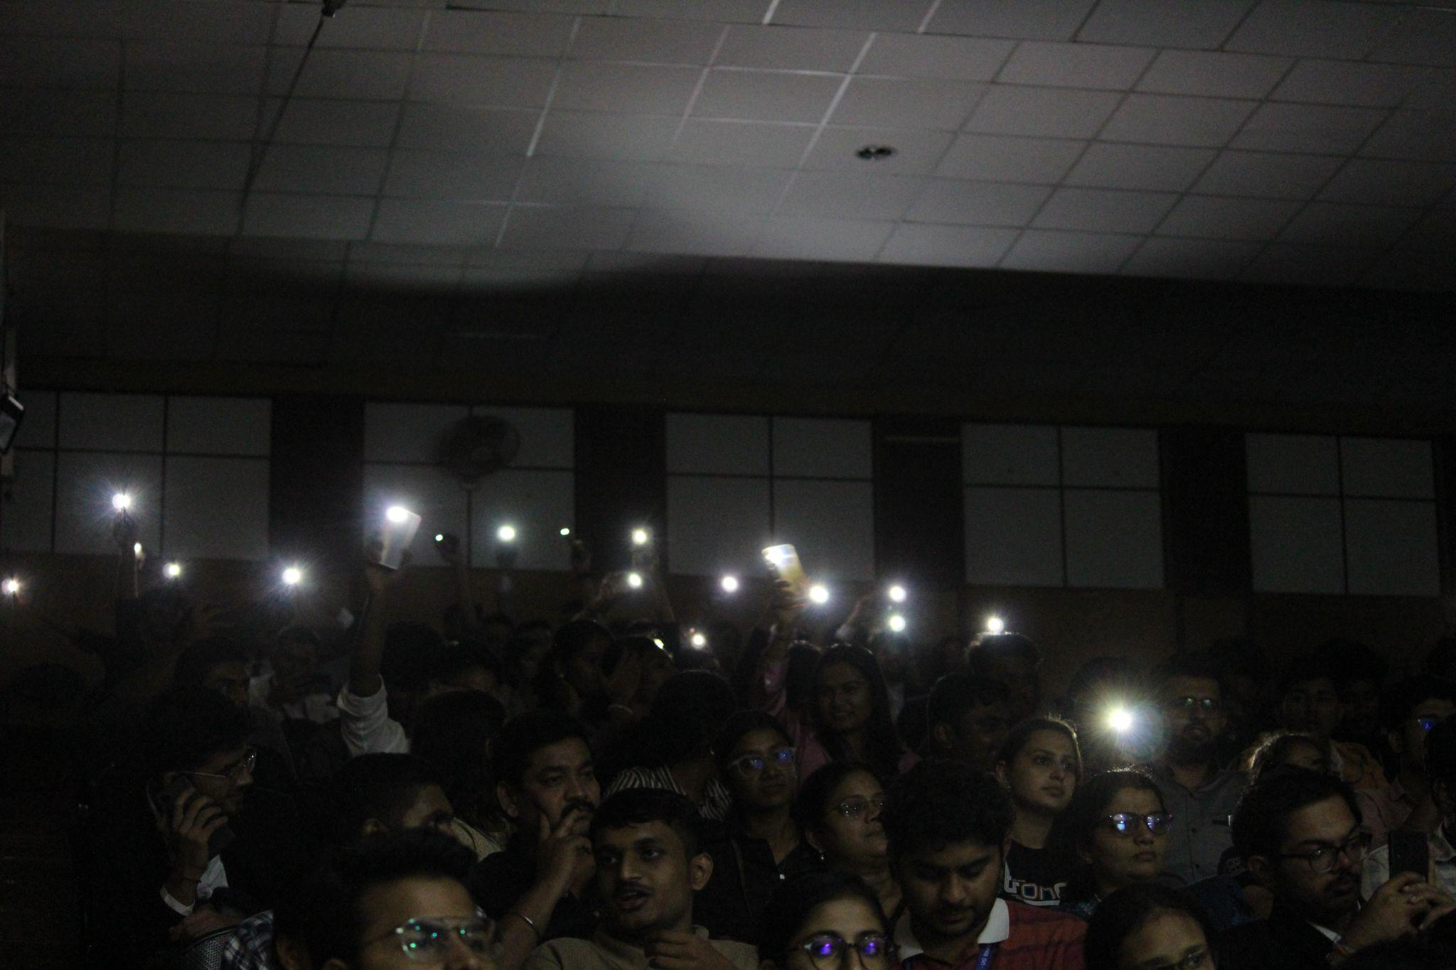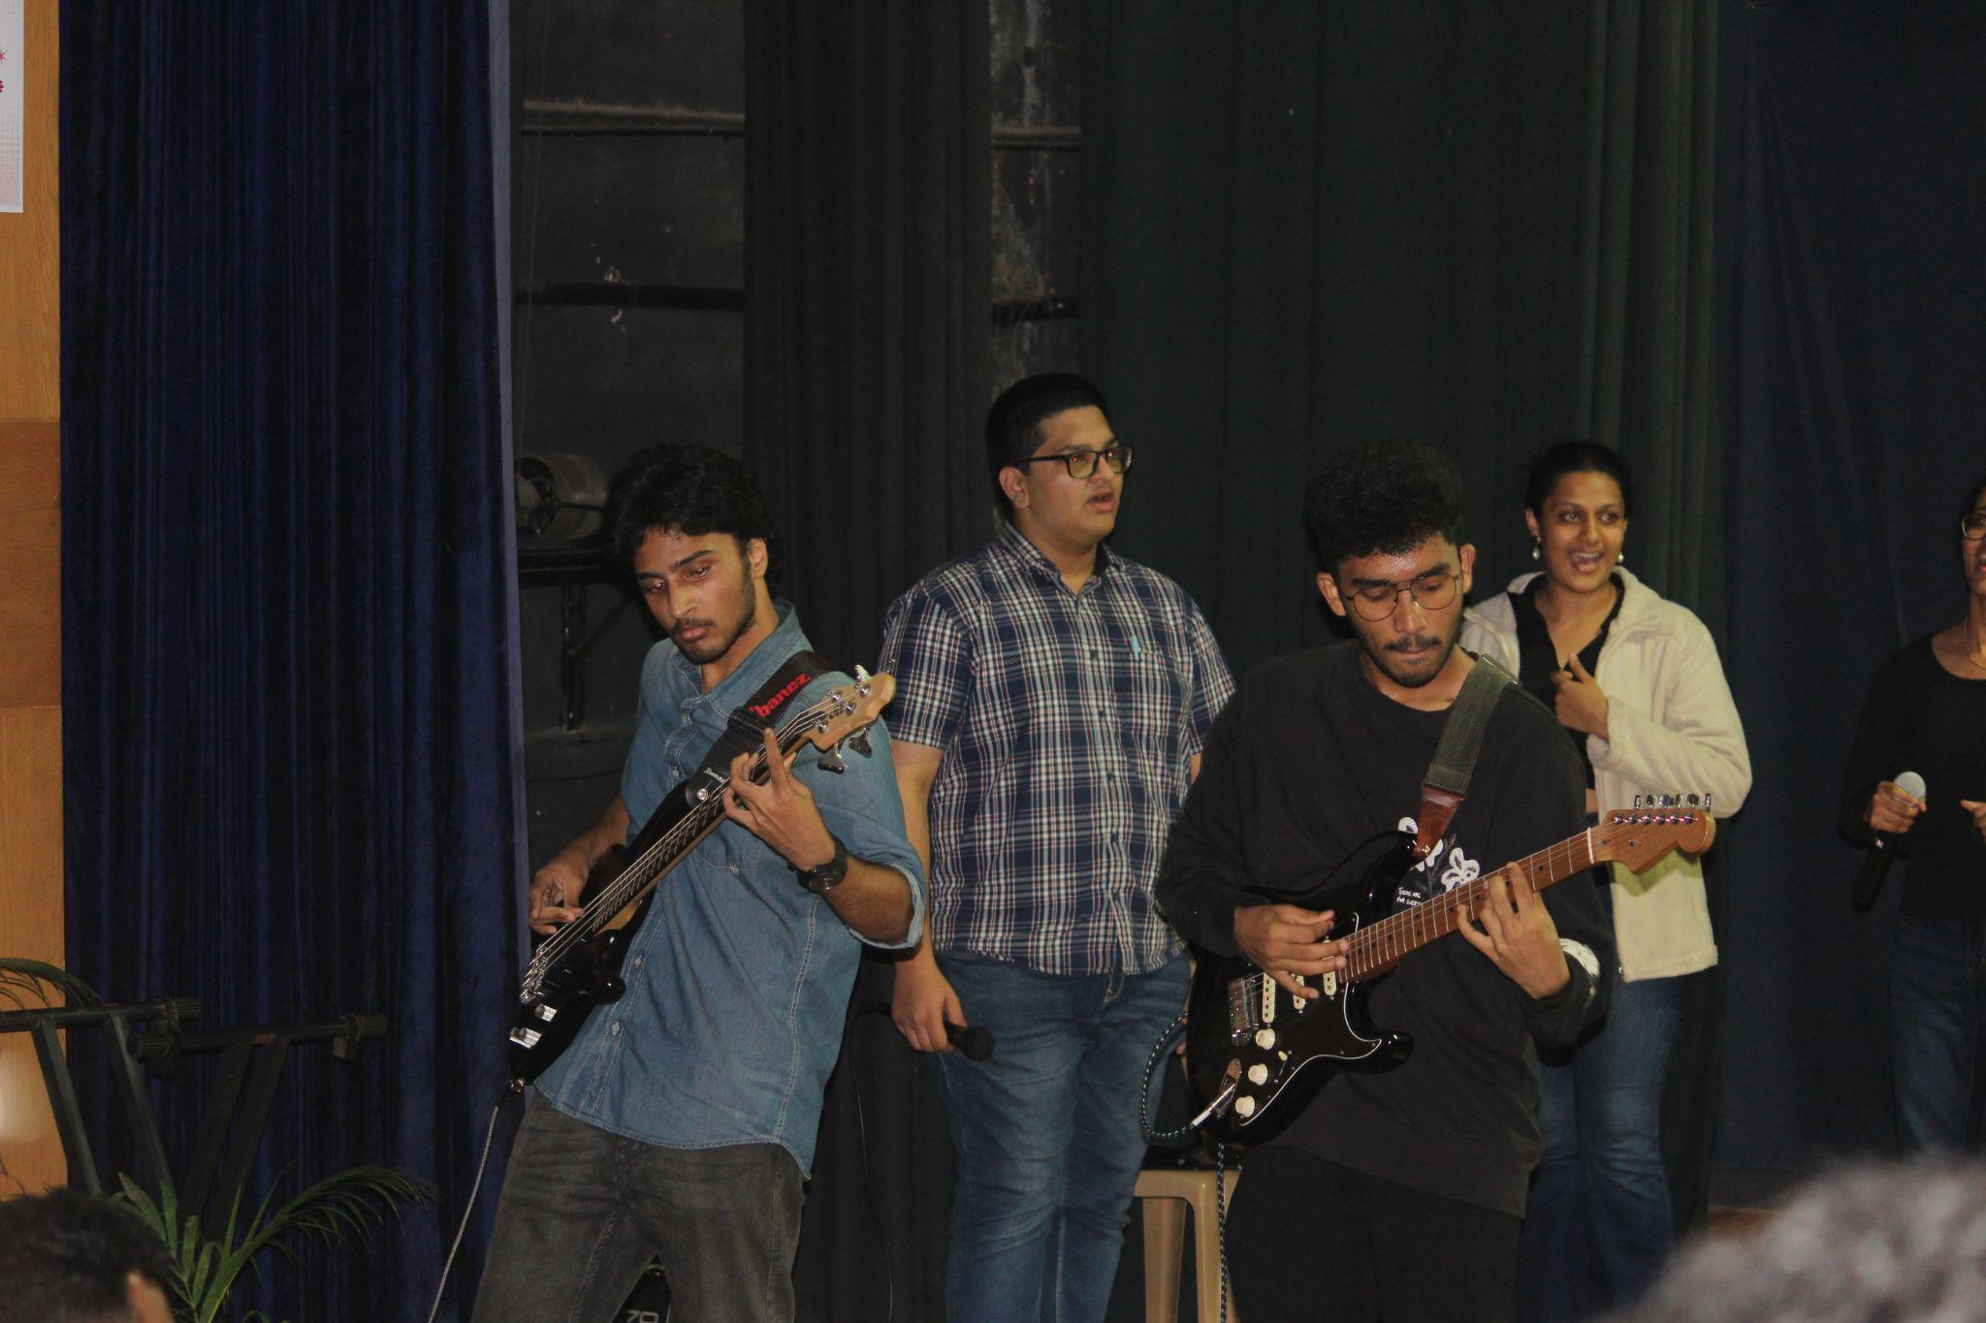

**DAY 2 - 21st December 2024**

### **9:00 AM to 10:00 AM – Breakfast**

The second day of the summit began with a delightful breakfast, providing participants an opportunity to recharge and connect with their peers. This informal setting allowed attendees to discuss their experiences from the previous day while looking forward to the insightful sessions ahead.

### **10:00 AM to 11:15 AM – Keynote 2: Online Education in the NEP Era**

**Prof. Andrew Thangaraj**, Chair at CODE and Professor of Electrical Engineering at IIT Madras, delivered an engaging keynote on the evolving landscape of online education in India, particularly in the context of the National Education Policy (NEP).

Key highlights of the talk included:

* **NPTEL (National Program on Technology Enhanced Learning):**
  + Overview of the SWAYAM platform.
  + The role and impact of NPTEL local chapters in promoting accessible education.
* **IIT Madras BS Degree through IITM CODE:**
  + Course structure and highlights.
  + Comprehensive learner support system and innovative research opportunities.
* **Collaborations:**
  + Establishing IITM CODE chapters to extend the benefits of the program across institutions.

Prof. Thangaraj emphasized the importance of leveraging technology to democratize education and make quality learning accessible to all.

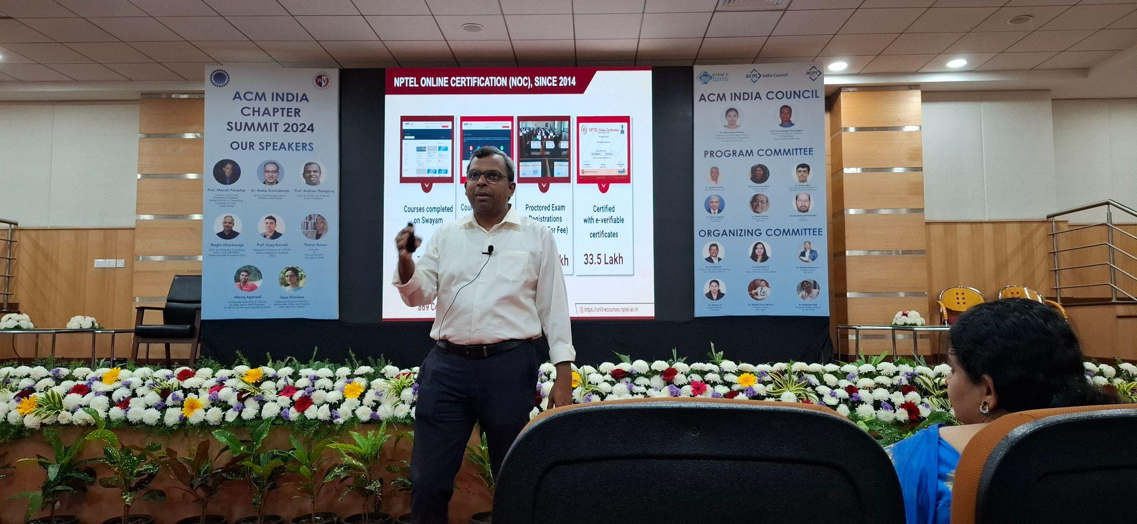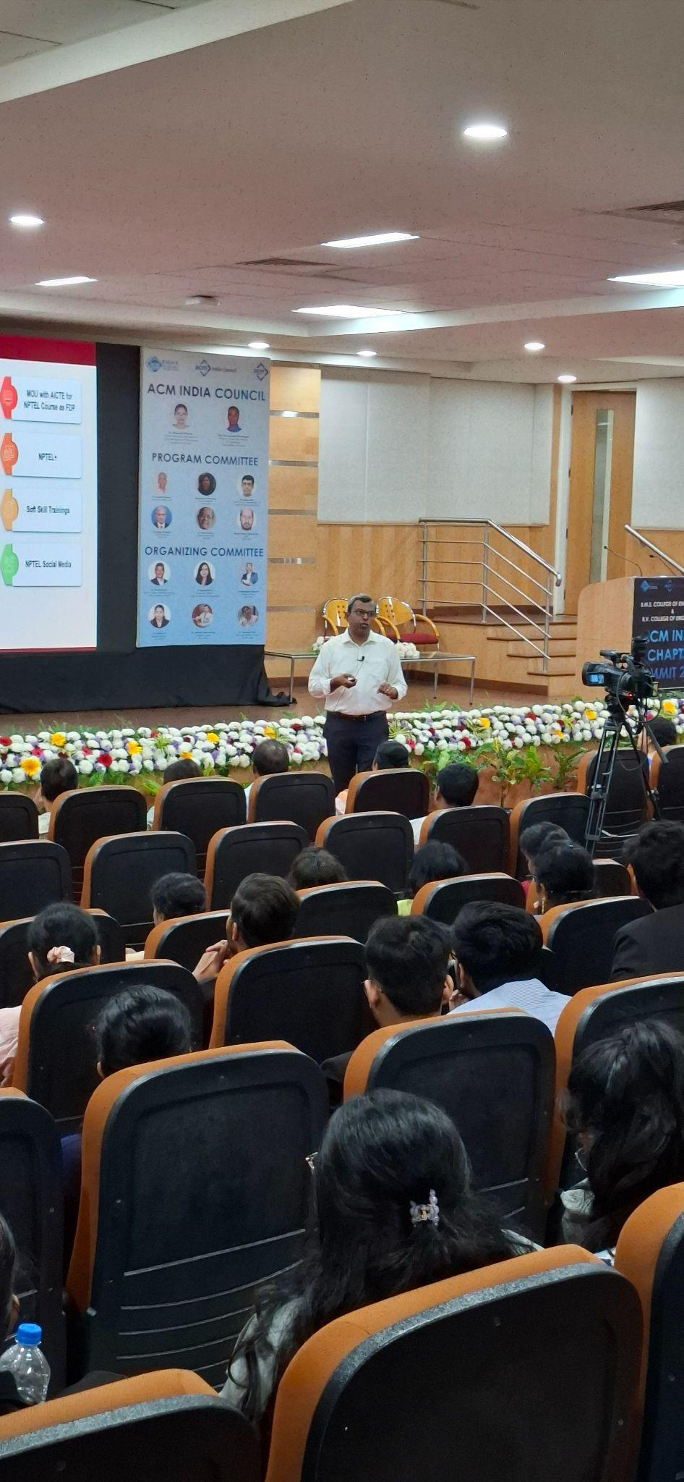

### **11:15 AM to 12:00 PM – Technical Session: 1. Regenerative Sustainability and Biomimicry - Tharun Kumar**, Founder and CEO of ECOSTP, who shared his expertise on **Regenerative Sustainability** and **Biomimicry.**

Key points covered:

* Introduction to regenerative sustainability and its transformative potential in resource management.
* Biomimicry basics and real-world examples of designs inspired by nature.
* Frameworks for applying biomimicry in sustainable innovations.
* Learning resources and links for further exploration.

**2.** **Beyond Scaling: Exploring Alternative Pathways to AI Intelligence - Manoj Agarwal,** Co-founder and CEO of Chief AI, and former Senior Staff Engineer at Uber and Principal Applied Scientist at Microsoft, **s**hared his insights on exploring alternative approaches to advancing AI intelligence.

Key points covered:

* Introduction to the limitations of scaling.
* Exploration of alternative pathways.
* Domain-specific AI applications.
* Ethical and responsible AI development.
* Future research directions.
* Learning resources and industry insights.

The session inspired participants to think creatively about addressing sustainability challenges using nature-inspired solutions.

### **12:00 PM to 12:15 PM – Tea Break and Networking**

Participants enjoyed a short tea break, exchanging ideas and building connections with fellow attendees and speakers in an informal setting.

### **12:15 PM to 1:15 PM – Keynote 3: Democratizing Data and Responsible Artificial Intelligence**

**Prof. Manish Parashar**, Director of the SCI Institute and Presidential Professor at the Kahlert School of Computing, University of Utah, delivered a thought-provoking keynote on **Democratizing Data** and **Responsible AI**.

Key highlights included:

* Overview of the **SCI Institute** and its focus on data and cyberinfrastructure.
* The transformative power of AI in science and society.
* Barriers to democratizing data and initiatives like the **NAIRR** to build an inclusive AI R&D ecosystem.
* Innovative tools and architectures such as the **NDP Overarching Architecture** and **Science Data Exchanges (SciDX)** to support data management and discovery.
* Foundations of responsible AI and their application in real-world scenarios.

Prof. Parashar emphasized the importance of equitable access to data and the ethical implications of AI development.

### **1:15 PM to 2:10 PM – Lunch & Networking**

During lunch, participants were divided into 6 regional groups and tasked with brainstorming action plans for the upcoming year. This collaborative session provided a valuable opportunity to exchange ideas, reflect on the morning’s discussions, and explore potential partnerships within their regions.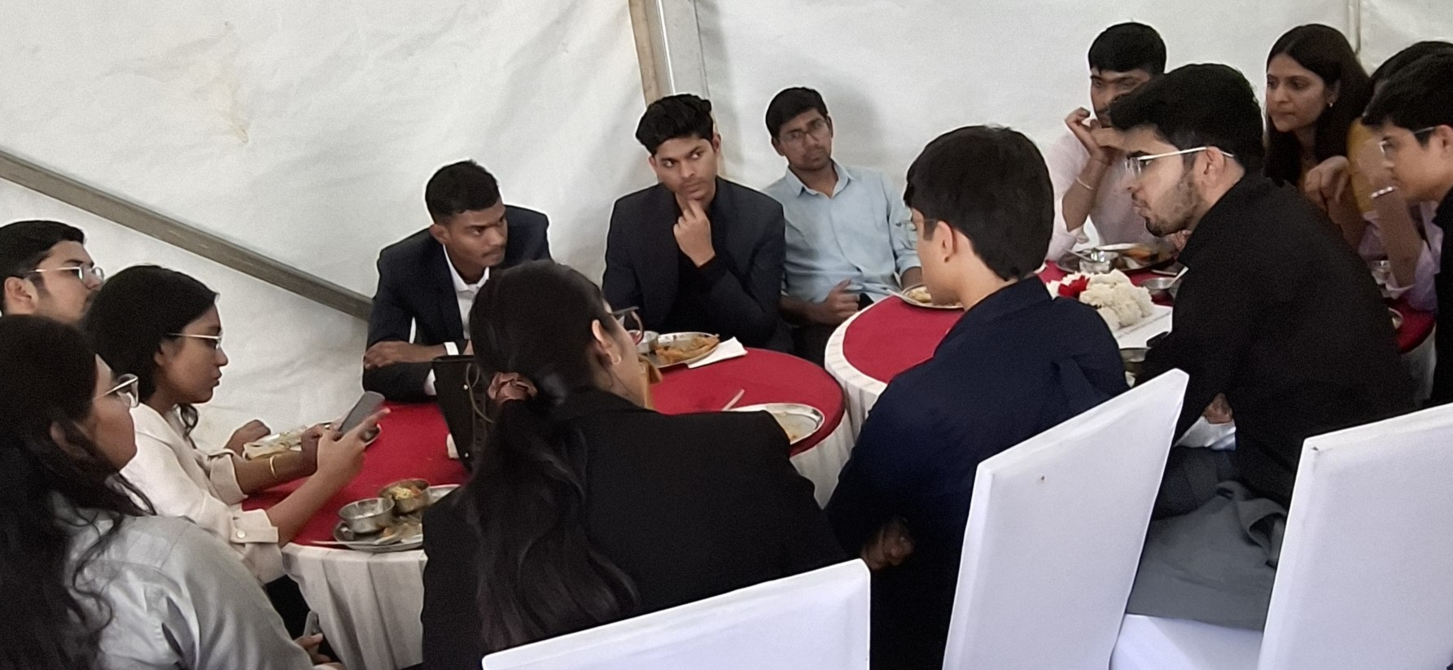

### **2:10 PM to 2:30 PM – Presentations**

### After brainstorming event ideas for the upcoming year during the lunch break, a representative from each region took the stage to present the ideas discussed by their respective groups.

### **2:30 PM to 3:15 PM – Keynote 4: Technology for Social Good**

**Raghu Dharmaraju**, CEO, AI & Robotics Technology Park (ARTPARK) at IISc, presented a captivating talk on leveraging technology for social good.

Key points covered:

* Establishing an innovation factory for next-generation AI and robotics.
* Supporting and incubating startups focused on societal impact.
* Developing AI solutions for frontline health workers, such as managing high-risk pregnancies.
* Open-source initiatives to promote accessibility in speech data.
* A framework for responsibly building AI solutions, emphasizing co-innovation with local communities.

His insights highlighted the potential of technology to transform underserved communities and create lasting impact.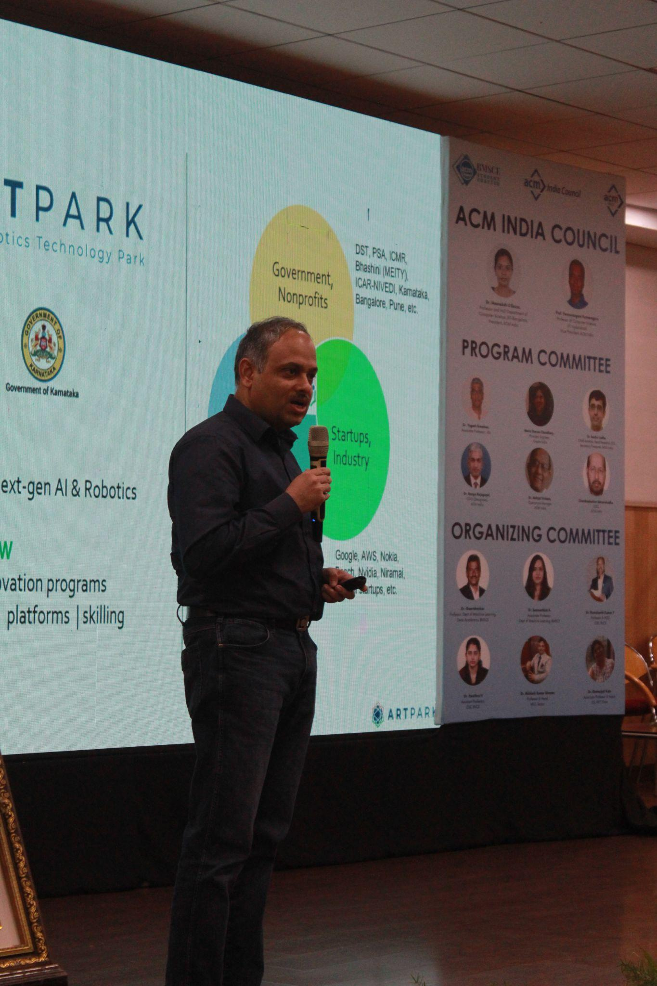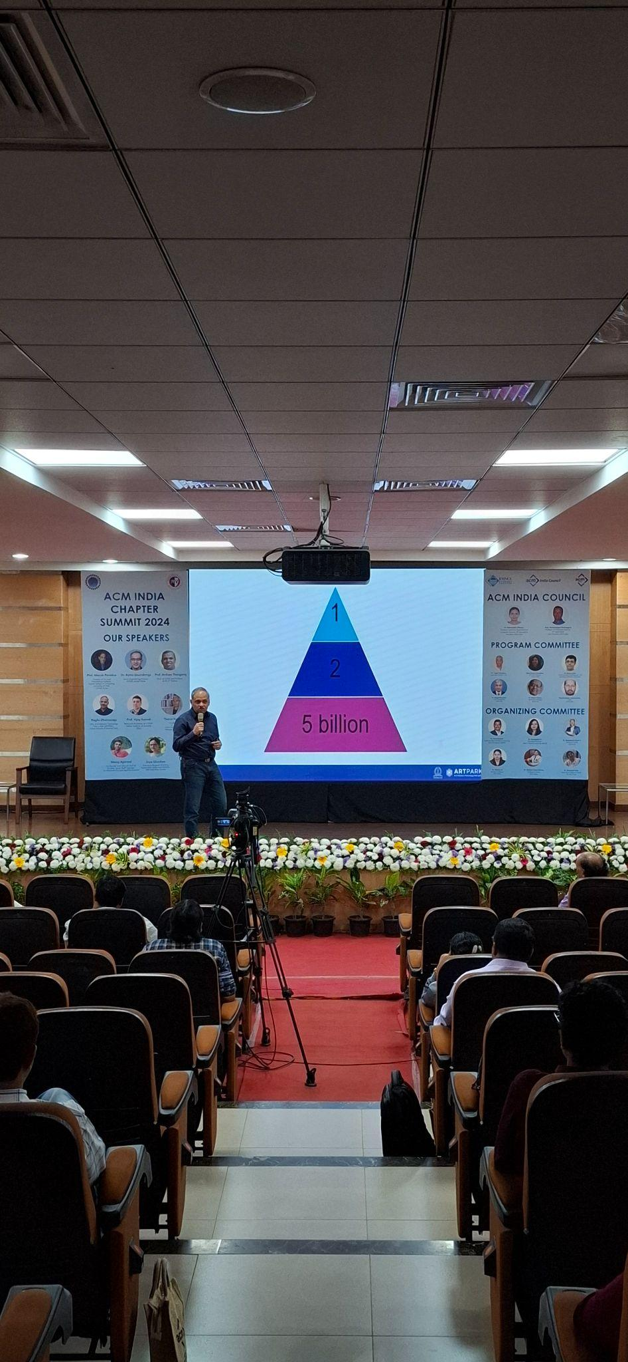

### **3:15 PM to 4:00 PM – Student Activity Planning**

Participants were divided into 13 groups to collaboratively develop one event idea they would like to conduct in their college or a potential collaboration within the region. Each group brainstormed ideas and outlined strategies to enhance ACM activities, fostering creativity and teamwork.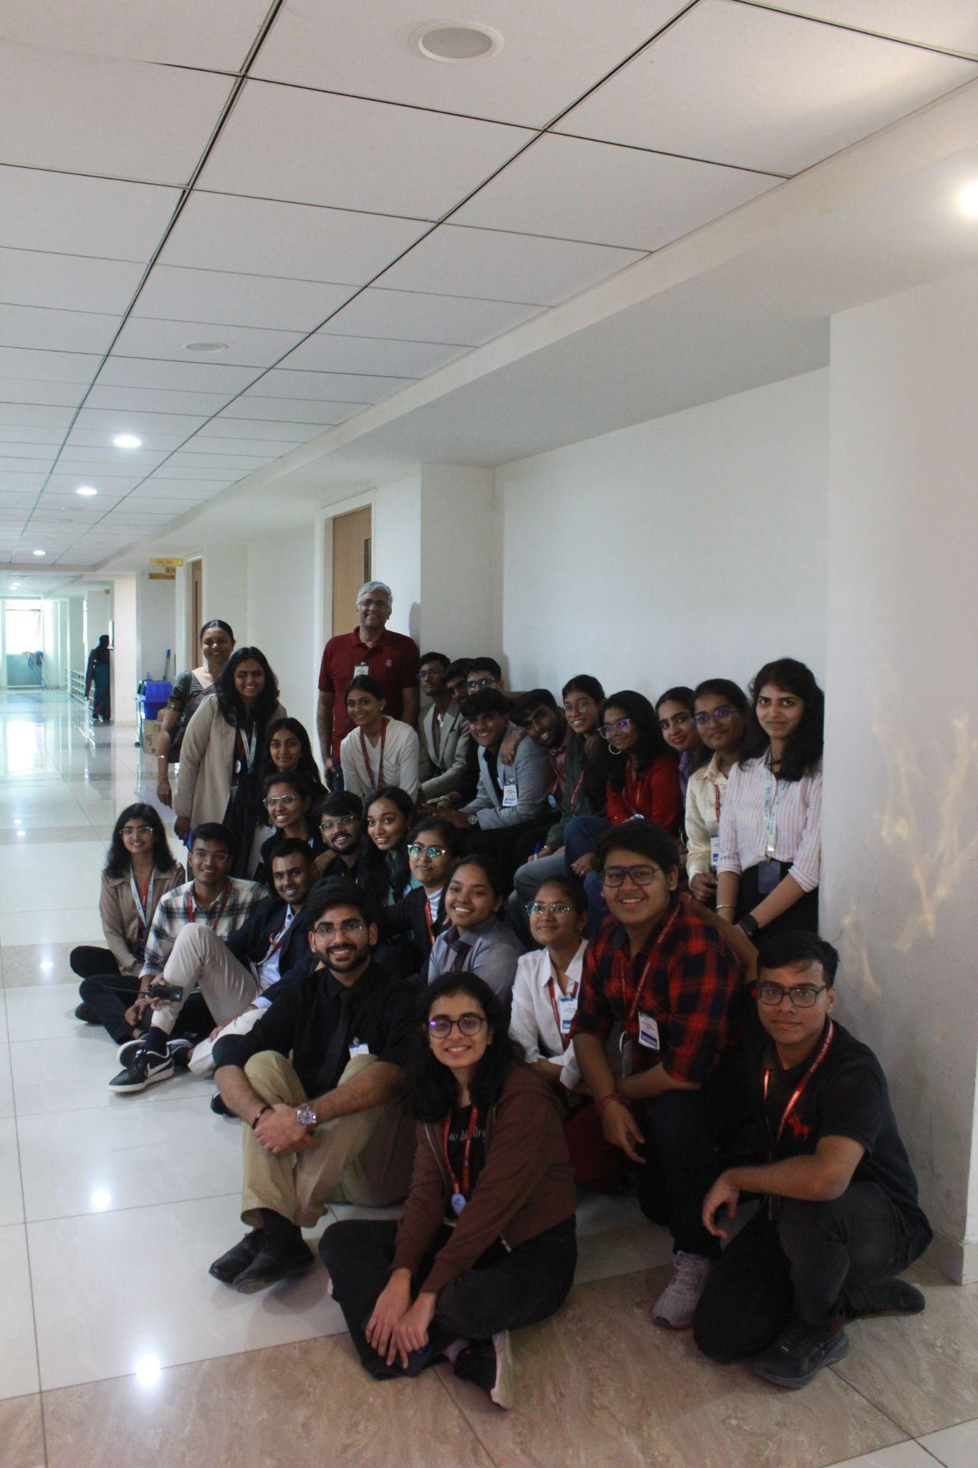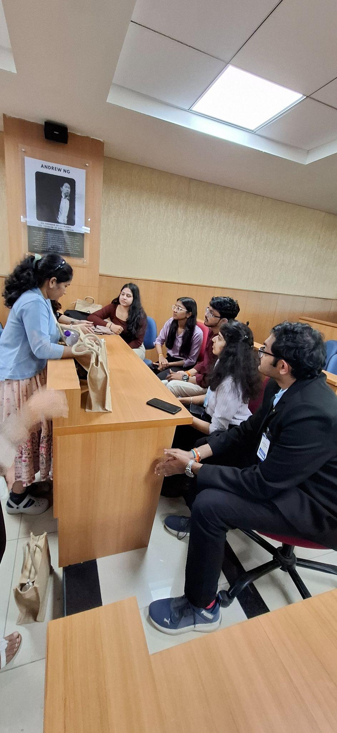

### 

### **4:00 PM to 4:30 PM – Peer Group Presentation and Closing Session**

The peer groups took to the stage to present their action plans, with each team allotted one minute to showcase their ideas. A panel of judges evaluated the presentations, ultimately selecting and announcing the top three teams as winners. The winners were awarded with ABF funding.

The closing ceremony featured heartfelt remarks from **Dr. Seemanthini K. Gowda**, Faculty Sponsor, BMSCE ACM Student Chapter, Associate Professor in the Department of AIML at BMSCE, who extended her sincere gratitude to the committee members, attendees, volunteers, and speakers for their pivotal contributions to the resounding success of the summit.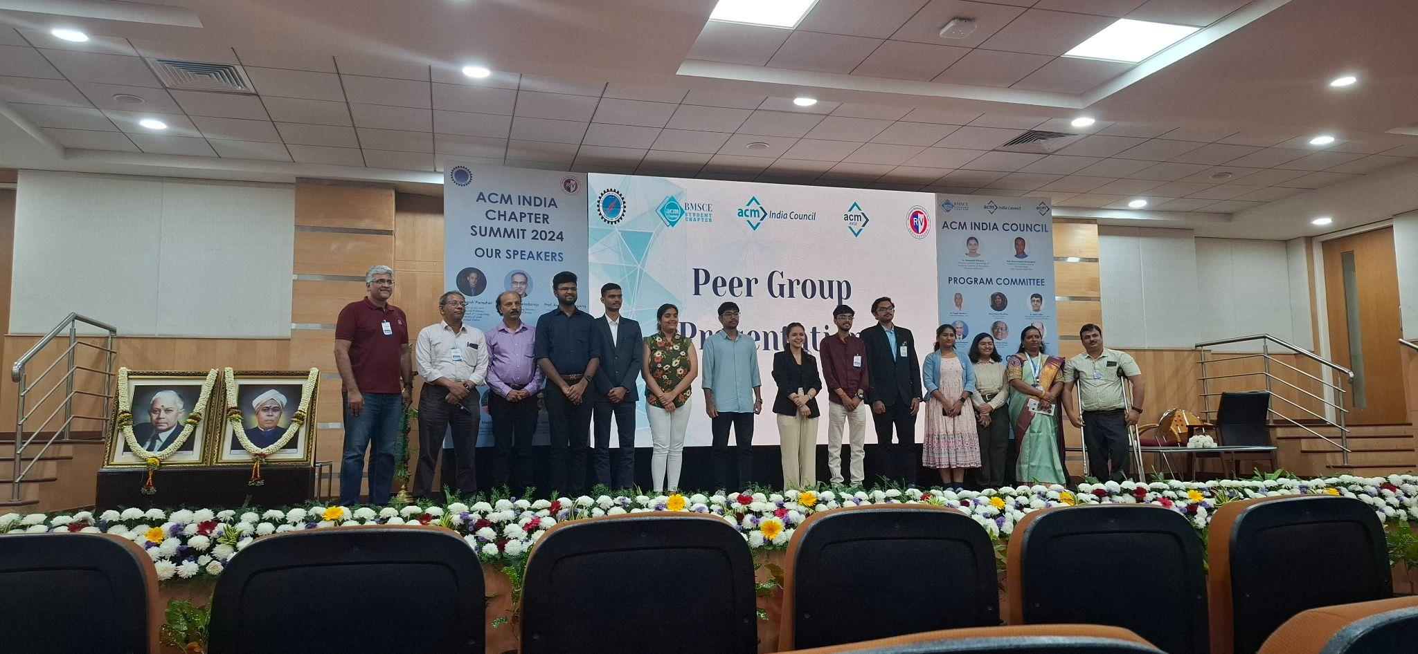

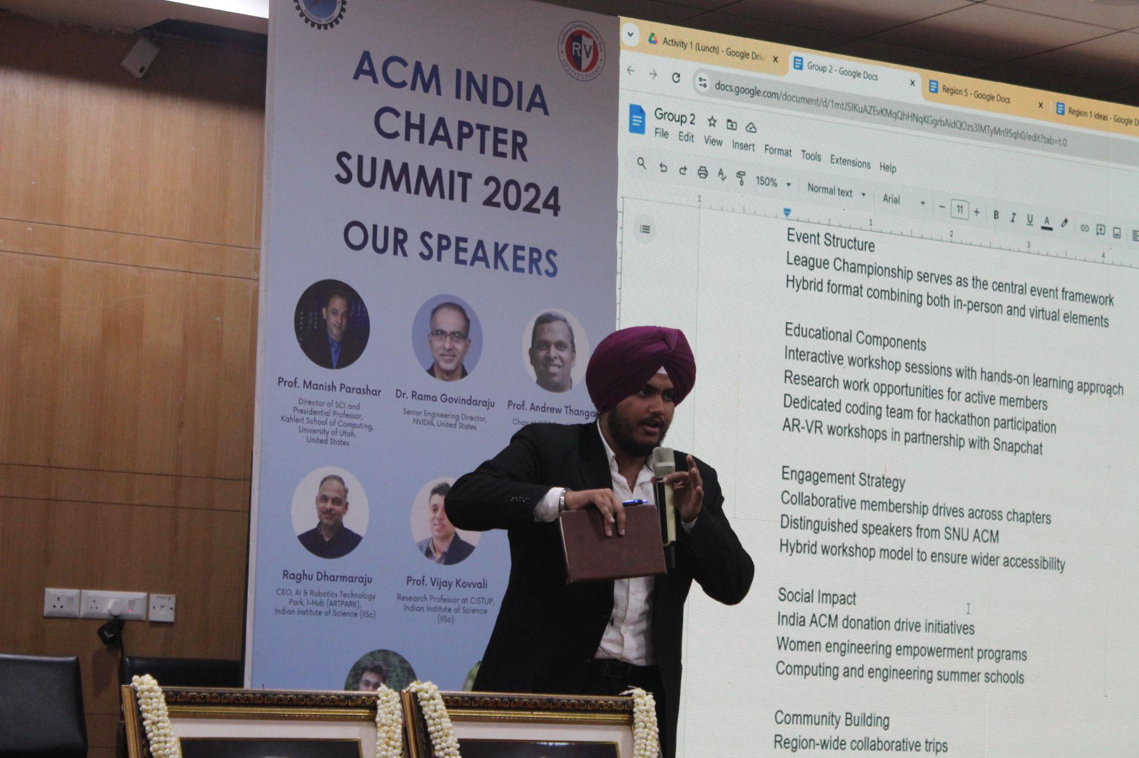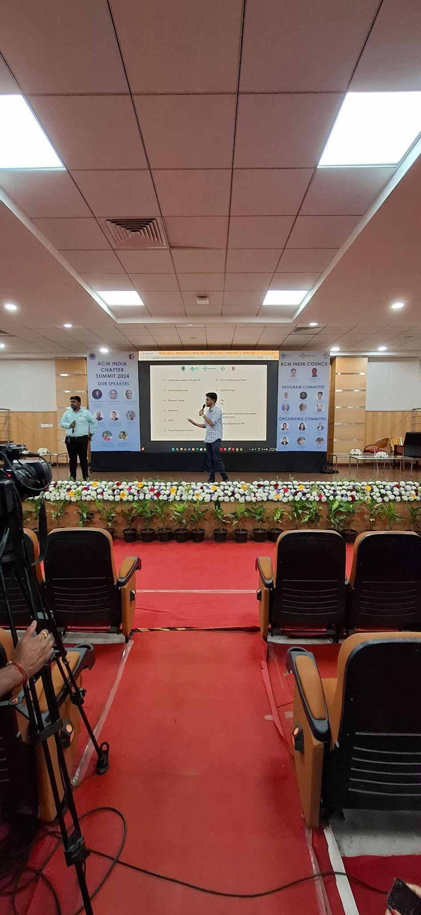

### **4:30 PM to 5:00 PM – Snacks Break**

Participants enjoyed light refreshments, marking the end of formal proceedings.

### **7:00 PM to 8:00 PM – Dinner**

The day concluded with a relaxing dinner, where participants reflected on the insights gained, celebrated their shared experiences, and strengthened the bonds formed during the summit.

**Registration And Count: Total count ( 202 )**

| **No. of Students** | **No. of Faculty** | **Total registrations** | **No. of Remote Chapters** | **No. of Professional Chapters** | **No. of Local Chapters** | **Total no. of Chapters** |
| --- | --- | --- | --- | --- | --- | --- |
| **138** | **64** | **202** | **74** | **6** | **7** | **87** |

**Chapter Attendees Details: (Total count: 177)**

| **Faculty Coordinators** | **Student Representatives** | **Professional Members** | **Host Institutes**  **Core & Volunteers** | **Council Members & Speakers** | **Total Count** |
| --- | --- | --- | --- | --- | --- |
| 49 | 122 | 6 | 112 | 15 | 304 |

**Key Achievements:**

* Seamless collaboration between BMSCE and RVCE ensured smooth execution of the summit.
* The theme "Sustainable Computing" inspired innovative discussions and ideas.
* Active participation from students, faculties from all ACM chapters and industry leaders enriched the event.
* Networking opportunities fostered collaboration among various ACM Chapters in India.

**Conclusion:**The ACM India Chapter Summit 2024 showcased how technology can play a vital role in promoting sustainability. With its theme, "Sustainable Computing," the event encouraged participants to explore innovative ideas and practical solutions for global challenges.

The summit brought together students, faculty, and industry leaders, creating a collaborative space for knowledge-sharing and networking. The seamless partnership between BMSCE and RVCE ensured the event ran smoothly, while the active involvement of ACM Chapters across the country strengthened the community's connections.

By fostering discussions, sparking innovation, and building collaborations, the summit highlighted the importance of sustainable practices in technology. The event ended on a positive note, leaving participants inspired and paving the way for more impactful initiatives in the future.

## **Committee:**

### **Organizing Committee Chairs**

Dr. Gowrishankar, Dean Academics, Professor, AIML, BMSCE

Dr. Seemanthini K, Associate Professor, AIML, BMSCE

Dr. Ramakanth Kumar P, Professor & HOD, CSE, RVCE

Dr. Pavithra H, Assistant Professor,CSE, RVCE

Dr. Geetanjali Kale, Associate Professor & Head, CE, PICT, Pune

Dr. Akhilesh Kumar Sharma, Professor & Head, MUJ, Jaipur

### **Program Committee Chairs**

Dr. Yogesh Simmhan, Associate Professor , IISc

Maria Dsouza Choudhary, Principal Engineer, Oracle India

Dr. Sachin Lodha, Chief Scientist, Head Research, TCS

Chandrashekhar Sahasrabudhe, COO, ACM India

Dr. Ranga Rajagopal, COO (Designate), ACM India

Dr. Abhijat Vichare, Operations Manager, ACM India

### **Student Coordinators**

G Sri Sai Meghana, Student Coordinator & Chair, BMSCE ACM Student Chapter

Srujana A Rao, Student Coordinator & Vice Chair, BMSCE ACM Student Chapter

Bhuvan Kumar S G, Student Coordinator & Treasurer, BMSCE ACM Student Chapter

Harshavardhan S, Student Coordinator & Secretary, BMSCE ACM Student Chapter

Sudeep S Rajpurohit, Student Coordinator & Web Master, BMSCE ACM Student Chapter

Manvendra Singh, Student Coordinator & Membership Chair, BMSCE ACM Student Chapter

Tanisha Agarwal, Student Coordinator & Chair, RVCE ACM Student Chapter

Ayush Ojha, Student Coordinator & Treasurer, RVCE ACM Student Chapter